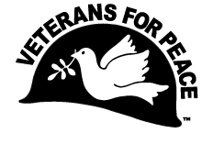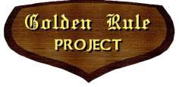**Ground Zero Center   
for Nonviolent Action**

16159 Clear Creek Road NW

Poulsbo, WA 98370

Veterans For Peace Golden Rule Project  
[vfpgoldenruleproject@gmail.com](http://www.vfpgoldenruleproject.org)www.vfpgoldenruleproject.org  
206-992-6364

[info@gzcenter.org](mailto:info@gzcenter.org)

[www.gzcenter.org](mailto:info@gzcenter.org)

FOR IMMEDIATE RELEASE

**Peace activists to meet the U.S. Navy Fleet arrival at Seafair on Tuesday, July 30, in Elliott Bay**

Contact: Glen Milner (206) 365-7865

Mary Gleysteen (360) 265-1589

Day of the event (206) 979-8319 Golden Rule coordinator Helen Jaccard, (206) 992-6364

Local activists will stage a **water-based nonviolent protest against the glorification of weapons of war at the Seattle Seafair** festival. Peace activists will meet the U.S. Navy fleet in Elliott Bay. The entire Seafair Fleet Week, featuring militarism and weapons of war, **is sponsored by the Boeing Company, the second largest military contractor in the U.S.**

This year the **Peace Fleet will be joined by the *Golden Rule* peace boat*.*** In 1958 activists sailed this little boat towards the Marshall Islands to stop nuclear weapons testing. Arrest of the crew in Honolulu sparked worldwide outrage, which helped President Kennedy decide to sign the Limited Nuclear Test Ban Treaty in 1963! The 1958 action inspired the founding of Greenpeace and many peace peace ships that followed.

Other peace activists will meet on the Seattle waterfront, at Pier 62 for a **nonviolent demonstration against weapons of war and against environmental harm caused by the U.S. military during Seafair**. See [Seafair Climate Action](https://www.seaclimateaction.info), www.seaclimateaction.info.

**What:** **Peace activists at Seafair**

**When: Tuesday, July 30, Noon, Peace Fleet in Elliott Bay.**

**Demonstration on land begin at 1 PM**

**Where: Elliott Bay and Pier 62**

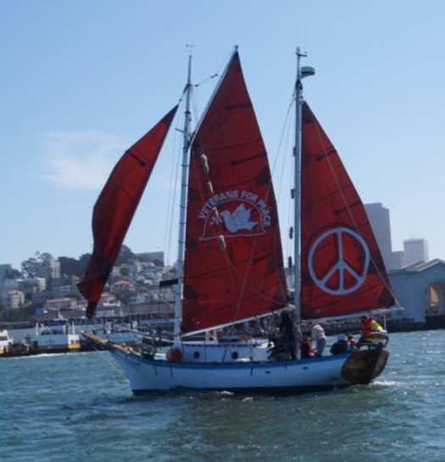

For the **twenty-third year**, peace activists will address the public display of warships and warplanes in our community.

The *[Golden Rule](http://www.vfpgoldenruleproject.org)* will be docked in [Bell Harbor Marina](https://www.portseattle.org/maritime/bell-harbor-marina) from July 29-August 1 and remain in Seattle until Aug 10.

For a tour of the boat, or to inquire about sailing, please contact:  
Helen Jaccard, Project Manager  
[vfpgoldenruleproject@gmail.com](mailto:vfpgoldenruleproject@gmail.com)  
206-992-6364

Why would we demonstrate for peace at a Seattle maritime festival? Because the **celebration of warships in our harbor helps bring about the normalcy of modern war.**

The **fleet arrival at Seafair is a public relations and recruiting event for the U.S. Navy**. Previous years have brought Trident nuclear submarines complete with nuclear warheads and Navy warships used to launch Tomahawk cruise missiles.  The fleet is displayed for four days in downtown Seattle at **tremendous cost to taxpayers while crucial social services in education, health care, and transportation are being cut for lack of funds.**

**The Peace Fleet is an incarnation of earlier waterborne demonstrations:** the People’s Blockade of U.S. Navy vessels carrying munitions during the Vietnam War; and the Peace Blockade near Hood Canal, demonstrating against the arrival of the first Trident submarine, the USS Ohio, at the Trident submarine base at Bangor in 1982.

The Peace Fleet began on **August 2, 2000 when the Trident submarine, USS Alabama, arrived in downtown Seattle for Seafair, complete with up to 192 nuclear warheads.**

The Peace Fleet this year, as in past years, will require no public funds or public resources.

End