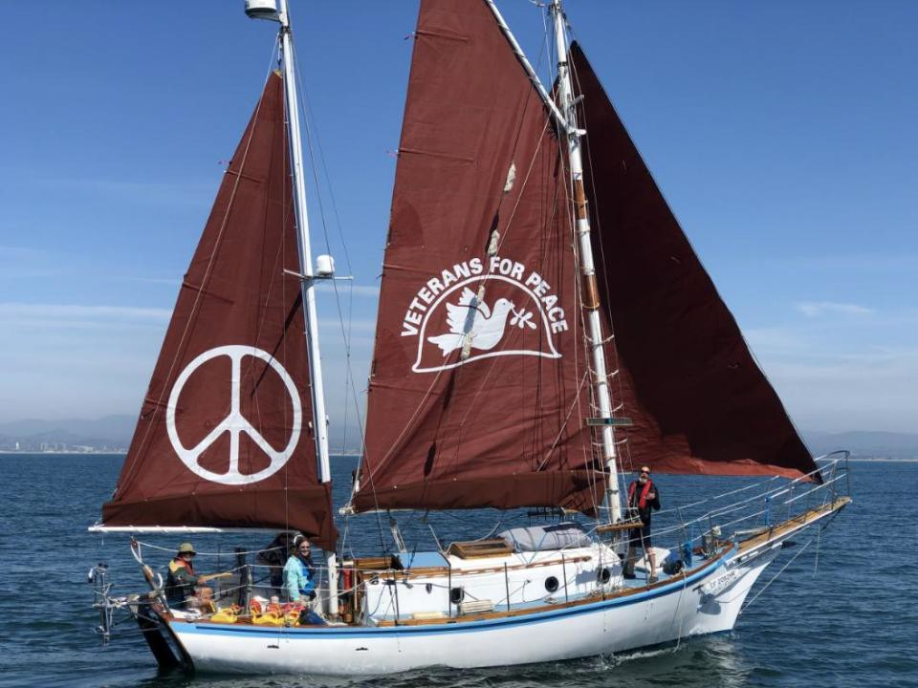
The Golden Rule:
Do Unto Others as you would have others do unto you

Golden Rule Sails Again for a Nuclear Free Future!
Veterans For Peace Golden Rule Project
www.vfpgoldenruleproject.org
vfpgoldenruleproject@gmail.com
(206) 992-6364
VFP Golden Rule Project
P.O. Box 87
Samoa, CA 95564

Golden Rule Project implements
Veterans For Peace Statement of Purpose
- To restrain our governments from intervening, overtly and covertly, in the internal affairs of other nations
- To end the arms race and to reduce and eventually eliminate nuclear weapons

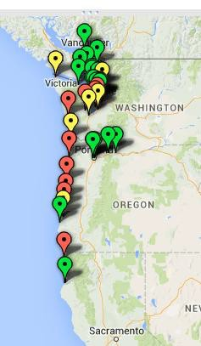
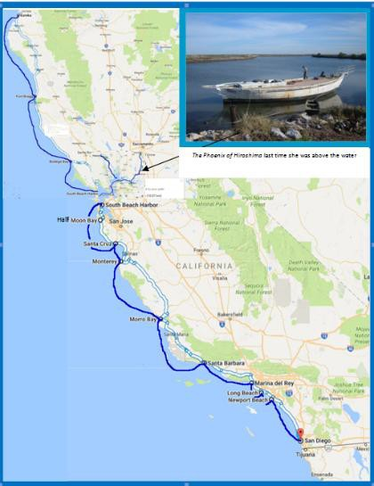
2016 Voyage 2015, 17-19,22

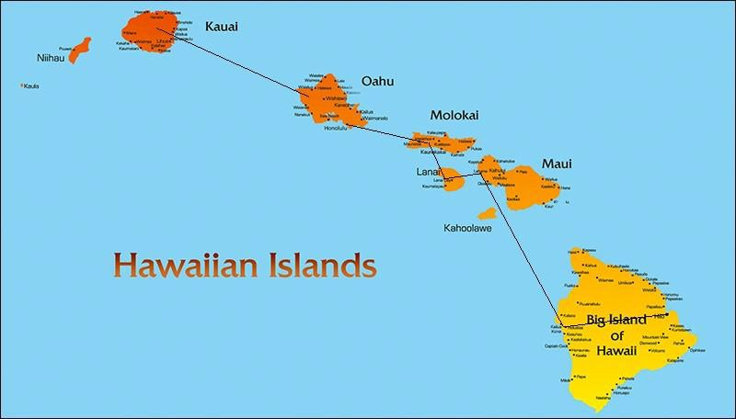
2019-21: 22 months in the Hawaiian Islands

“The Great Loop”
Minneapolis Aug‘22 - Chicago Sept ‘23

  - 10,300 miles
  - 102 Cities or Towns visited
  - 350 presentations -
reached 10,500 people directly
VFP Chapters
22 Chapters donated a total of
$23,652 in 2022-23.
39 Chapters anchored GR GL Events

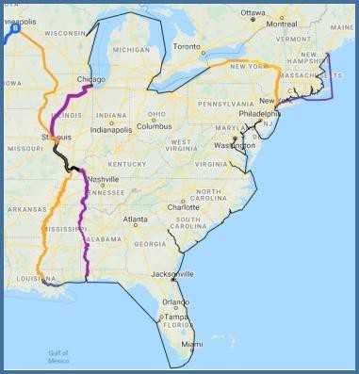
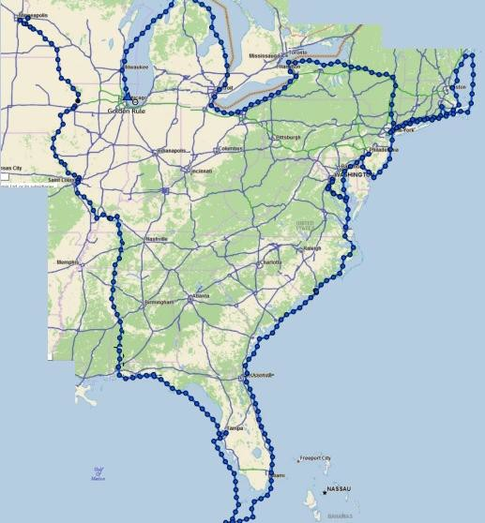
100,000s of people reached through press

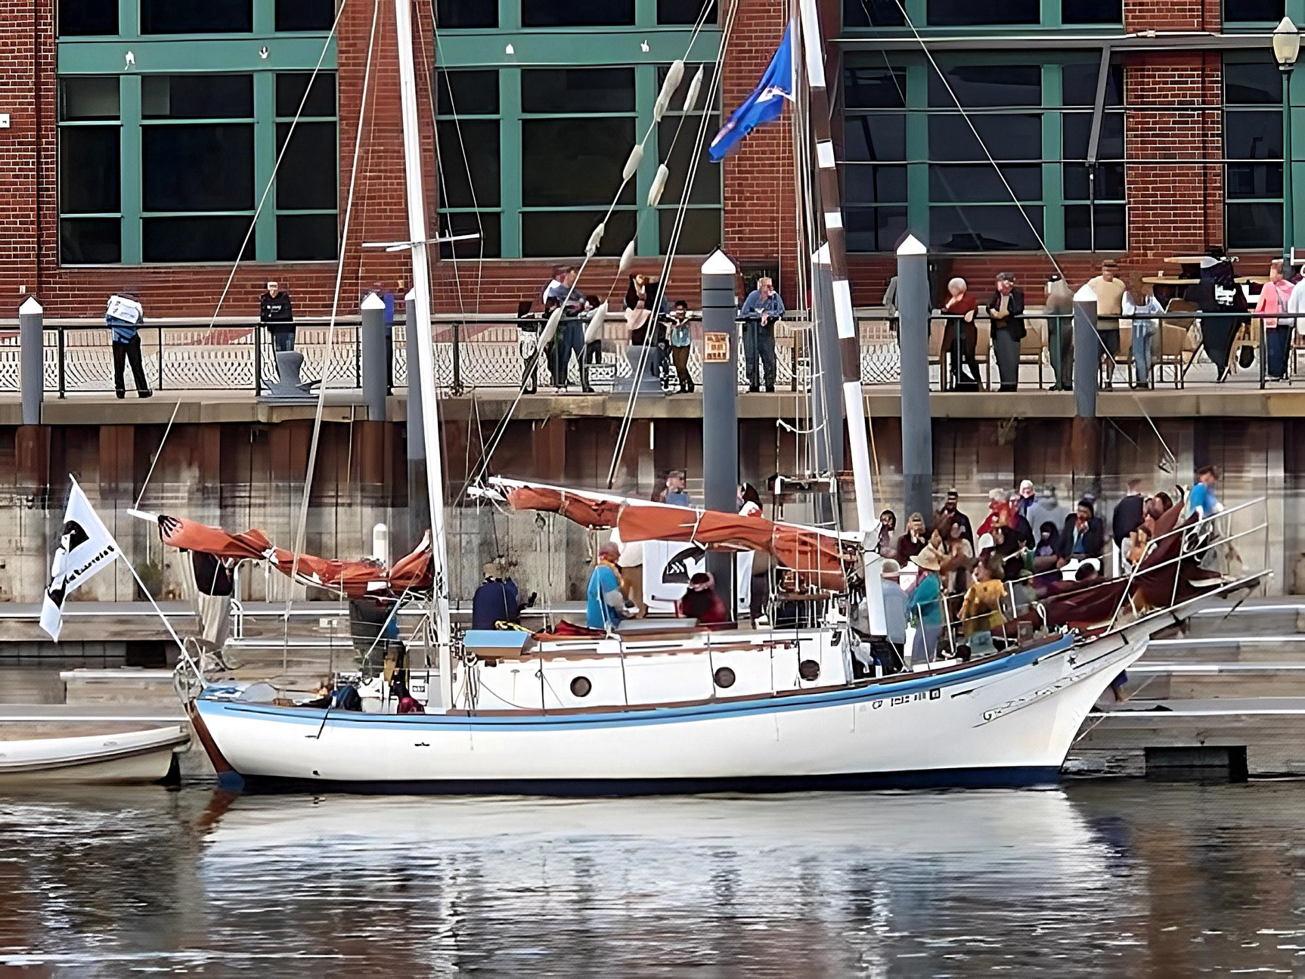

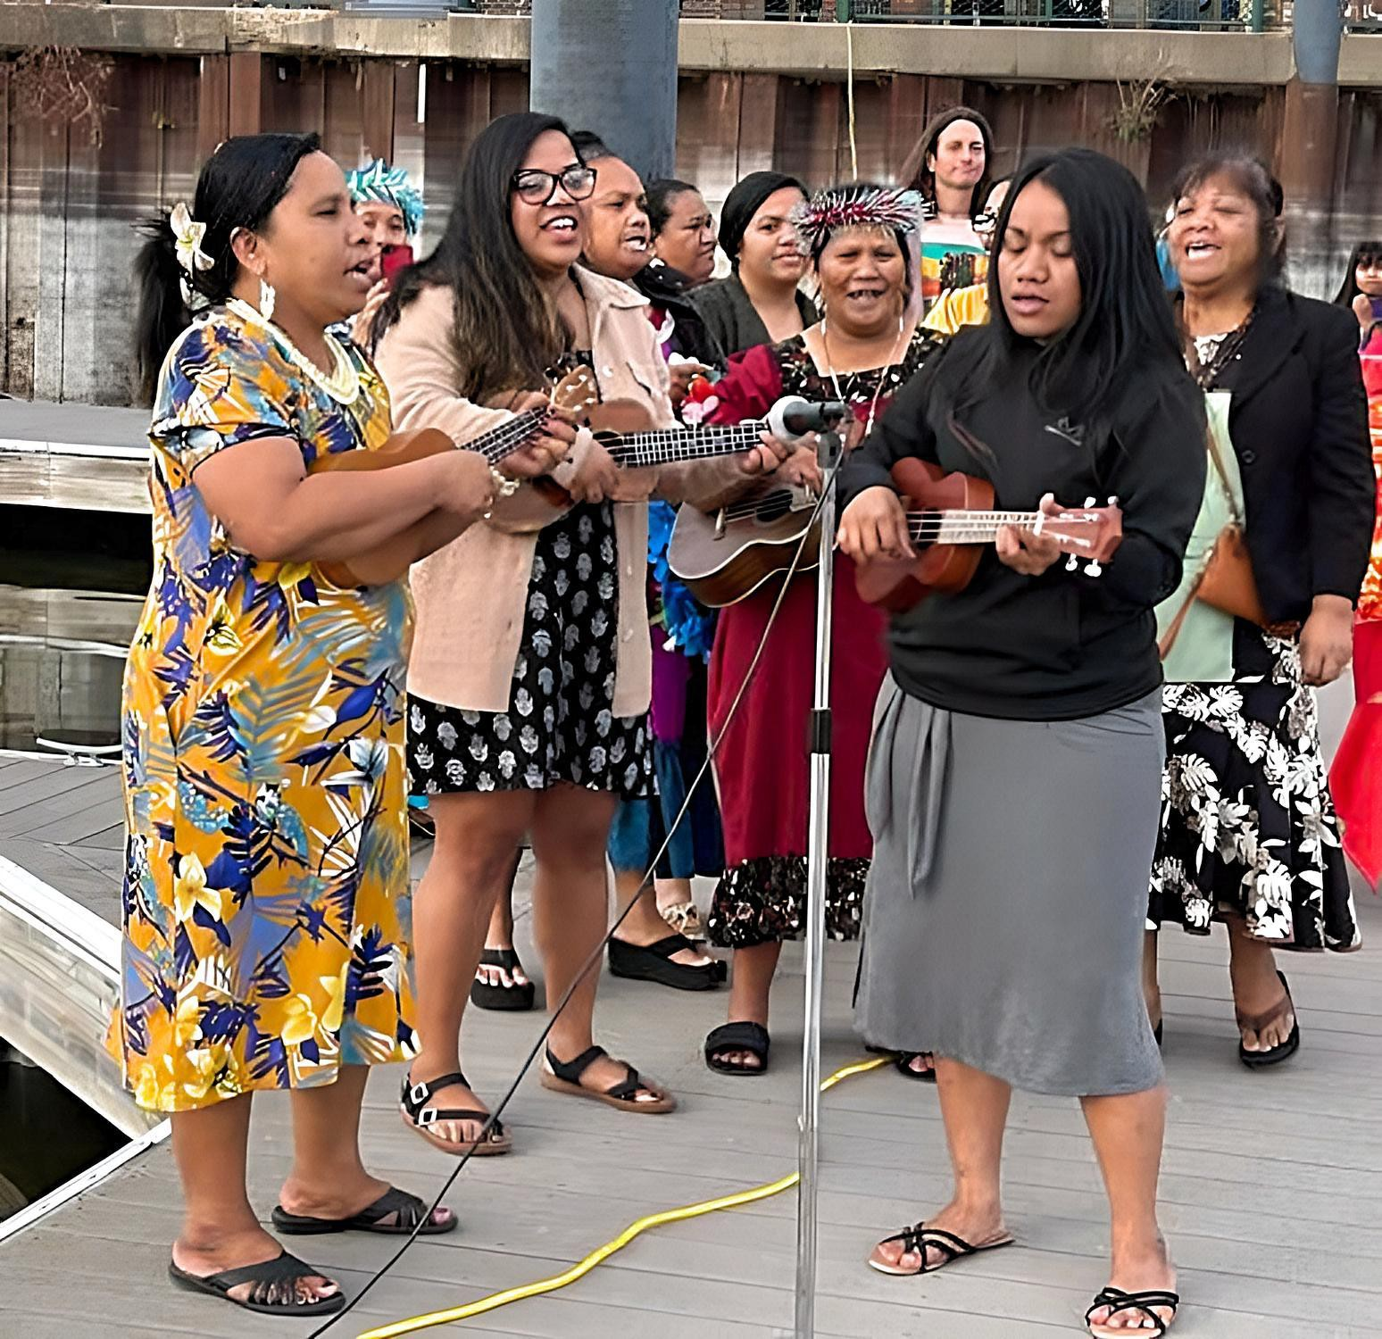

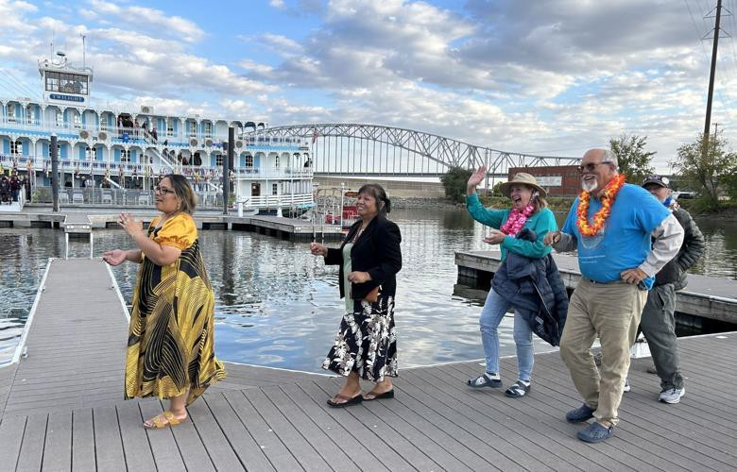

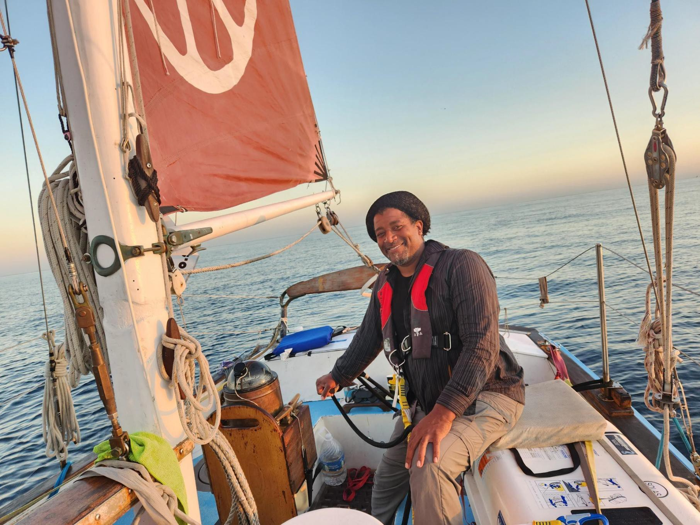
2023 Started with the voyage to Cuba!
Six Golden Rule representatives went by sea and five by air to Cuba for an “Arts & Cultural” visit
Dec 31 - Jan 10

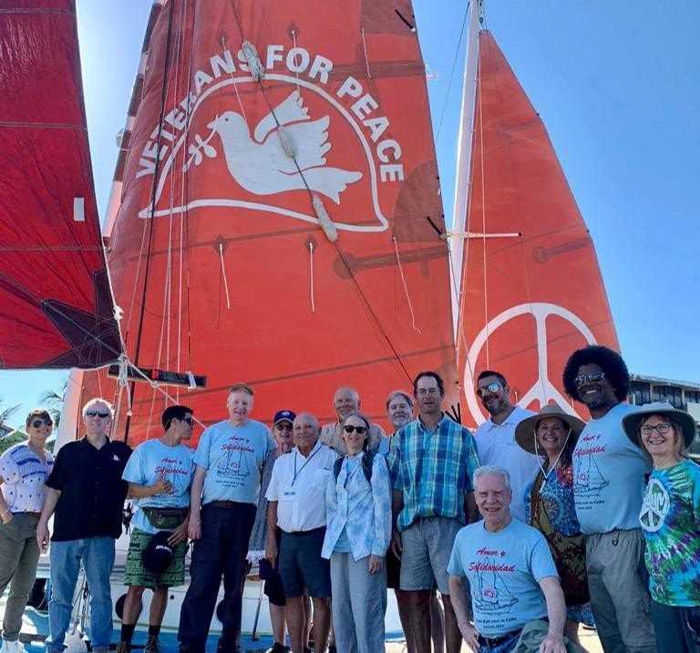

The Entire Cuba Delegation (from land and sea!)

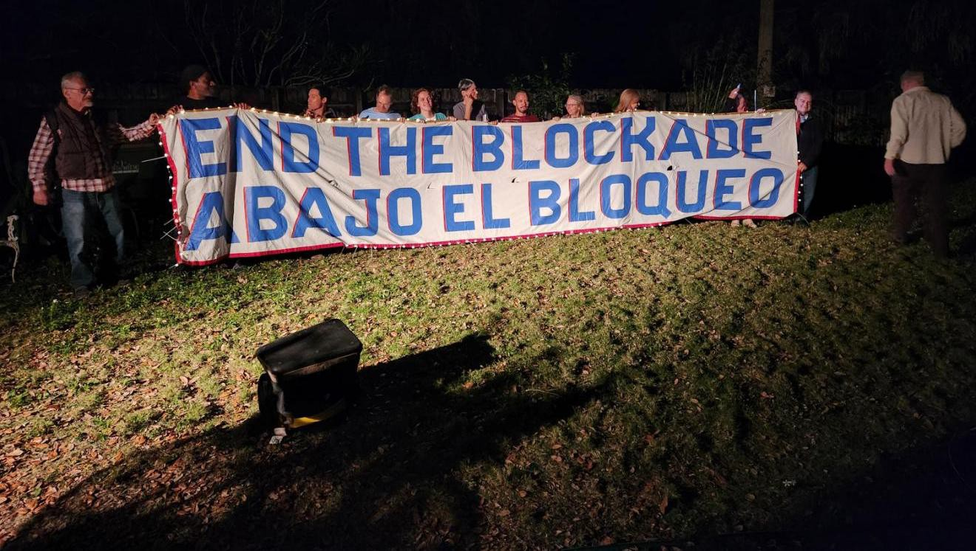
Golden Rule Reps joined Miami activists to call for the end of the Cuba Blockade

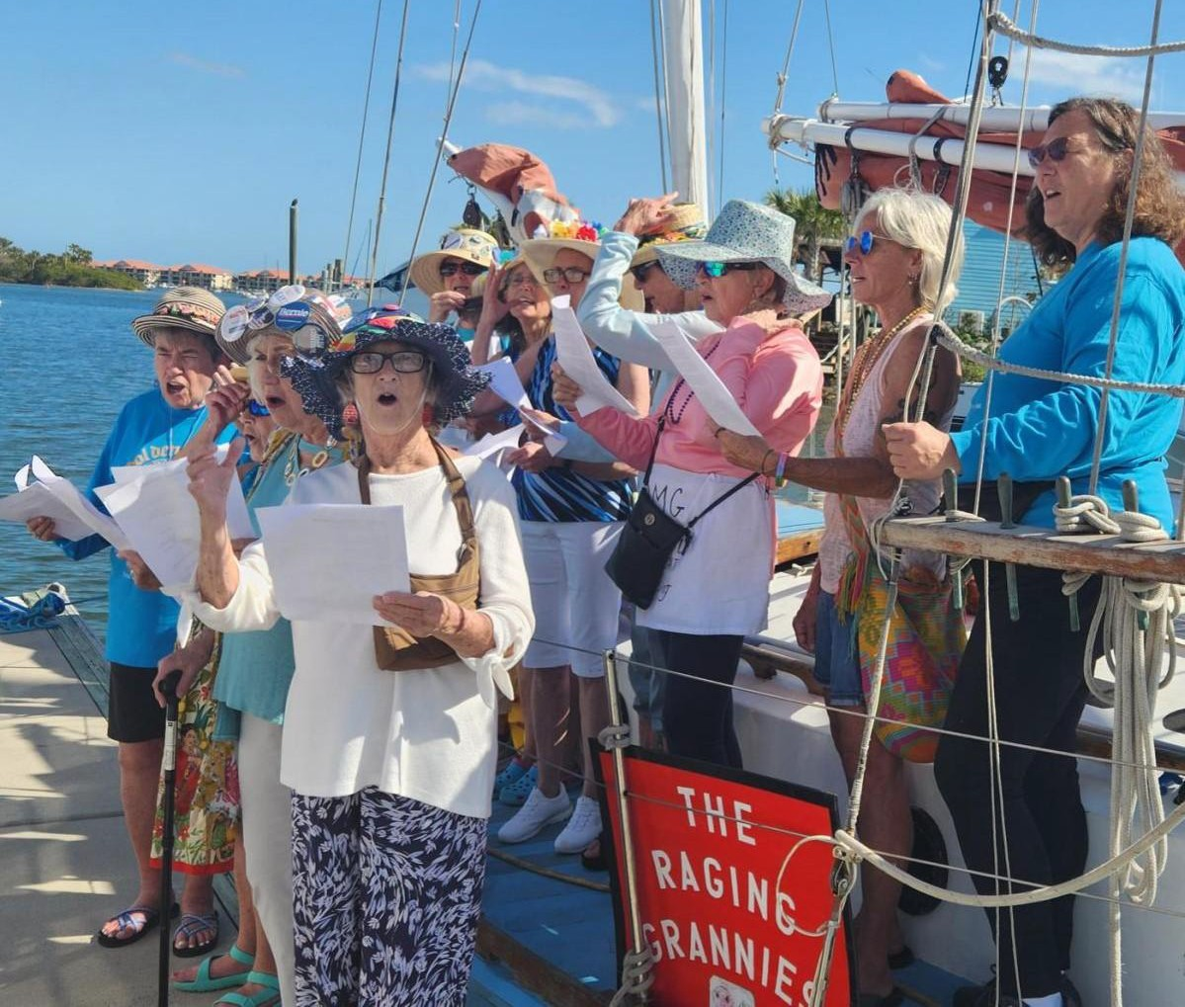

January - Miami, New Smyrna
The Raging Grannies sang and Citizens welcomed the Golden Rule
We interacted with many groups of faith:
Friends Meetings, Soka Gakkai Buddhists, Buddhist Mahayana sect from Vietnam Retreat Center,
Activists: Hands Off Cuba!, Raging Grannies, CodePink

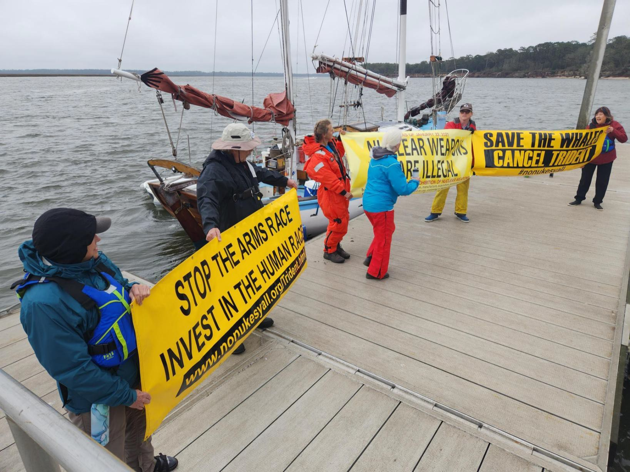
February: Jacksonville, FL, coast of Georgia
Nuclear Watch South, Sail-by and Protest at Kings Bay Nuclear-Armed Trident Submarine Base!

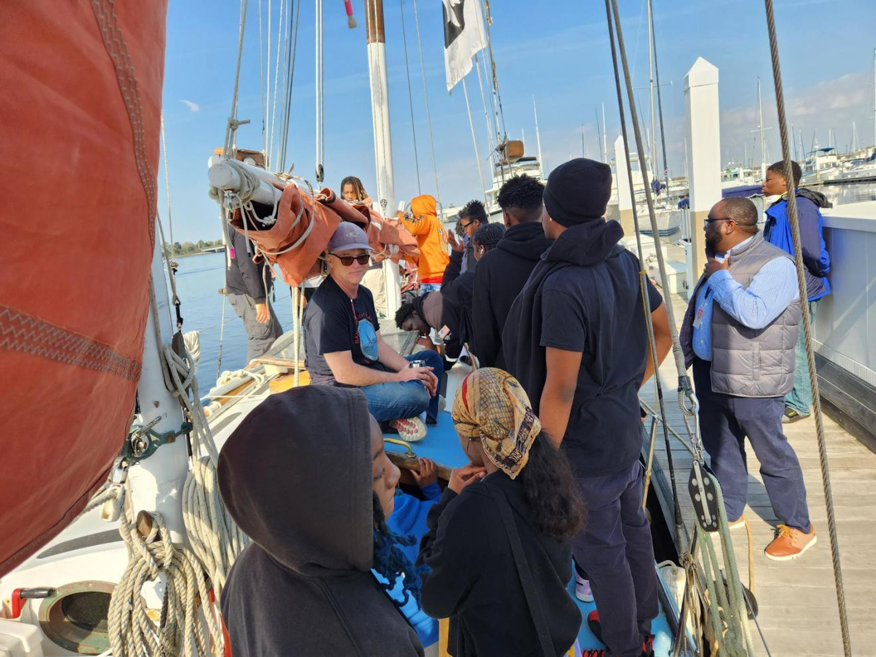
Black high school students visit the Golden Rule

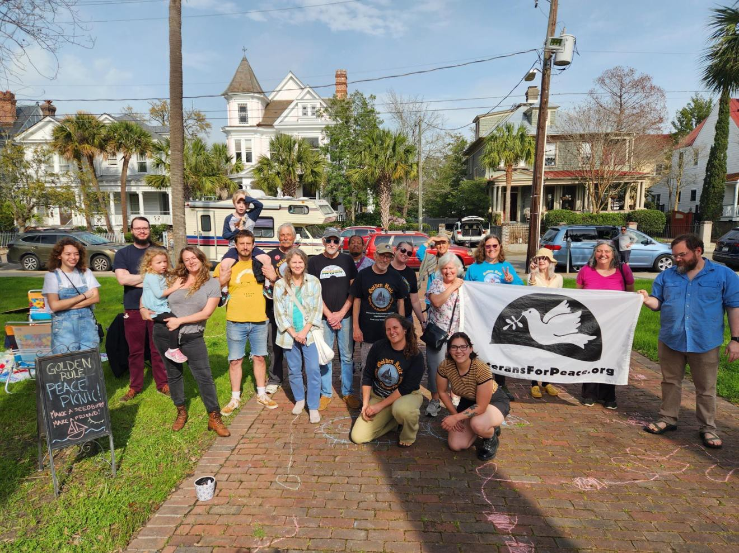
Peace picnics in the park!

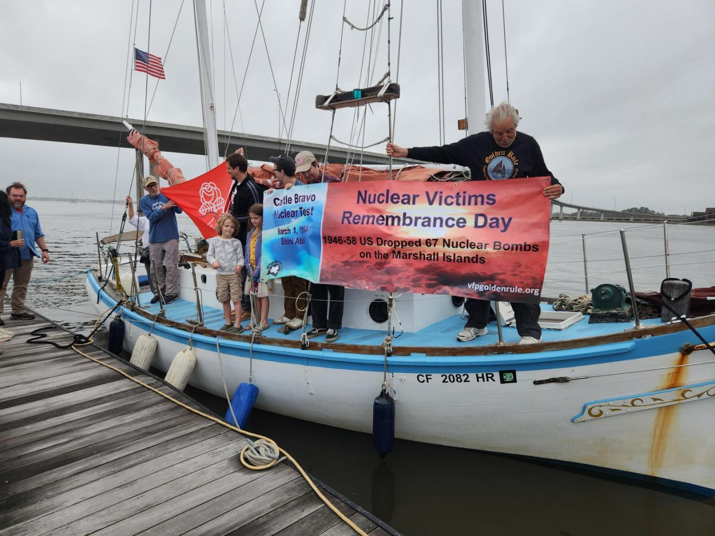
Commemorating March 1, 1954 Castle Bravo destruction in the Marshall Islands

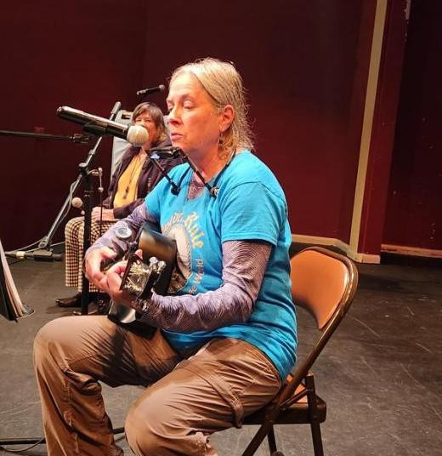
Activist Joanne Sweeney entertained us with peace folk music

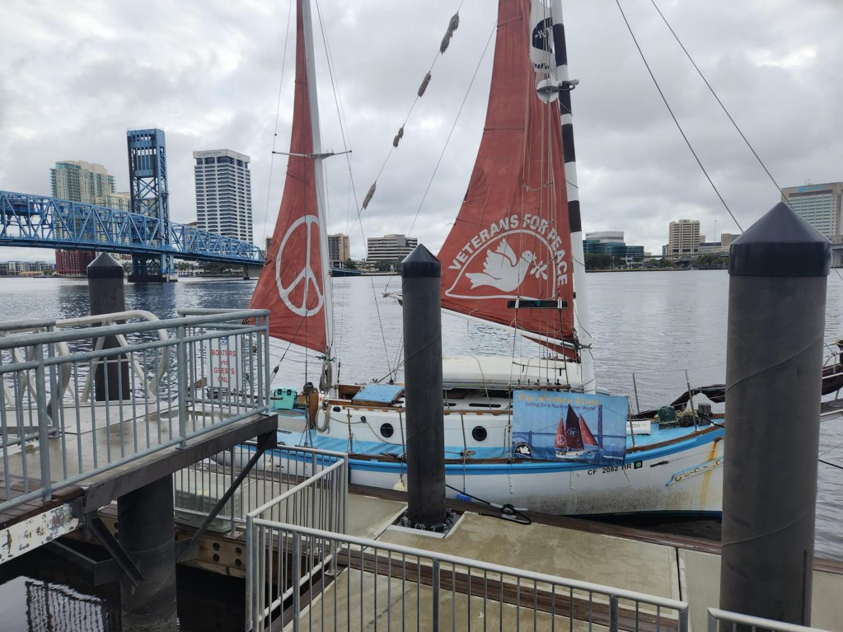
We fly the sails whenever possible!

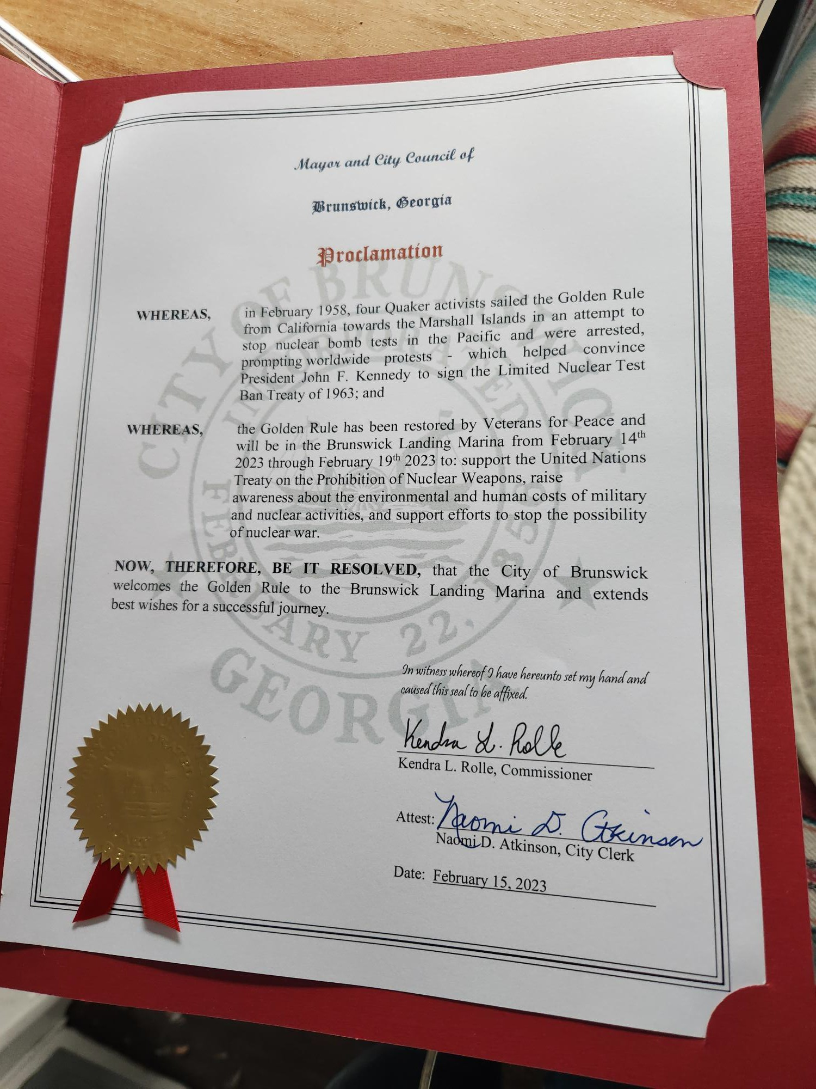
Over 40 Mayors and City Councils gave the Golden Rule a warm Proclamation of Welcome!

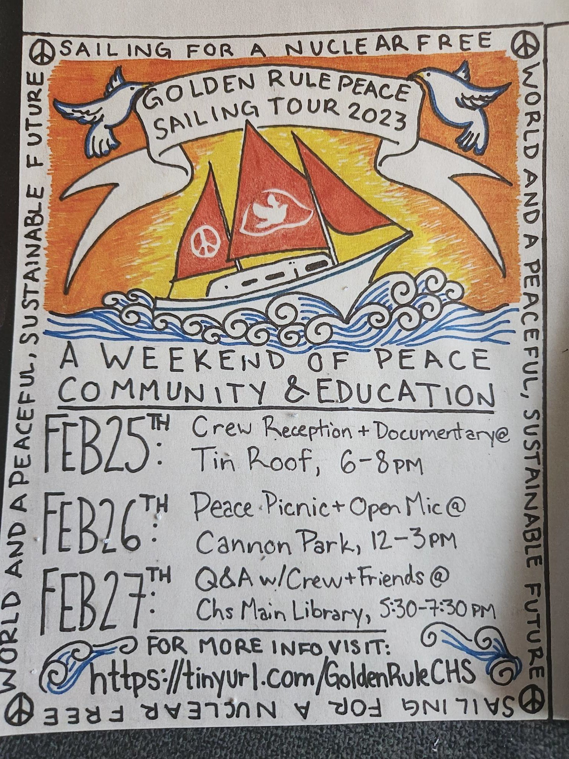
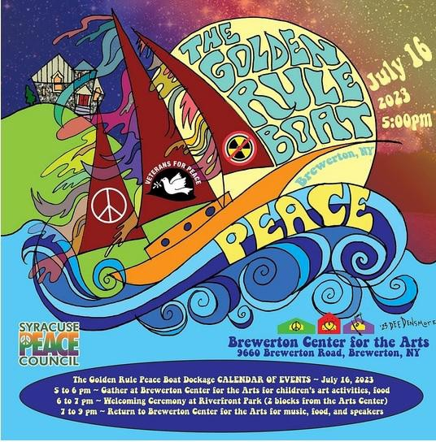
Beautiful Unique flyers

Fleet Week Parade of War Ships, Hudson River, NYC
New Haven, Connecticut welcomed the Golden Rule - several groups sailed by Groton Electric Boat, manufacturer of nuclear-armed submarines.

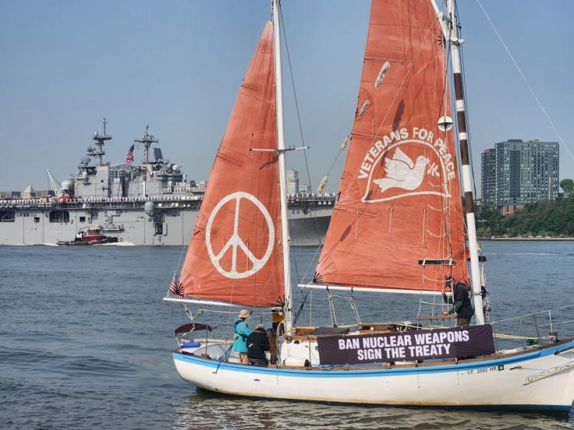
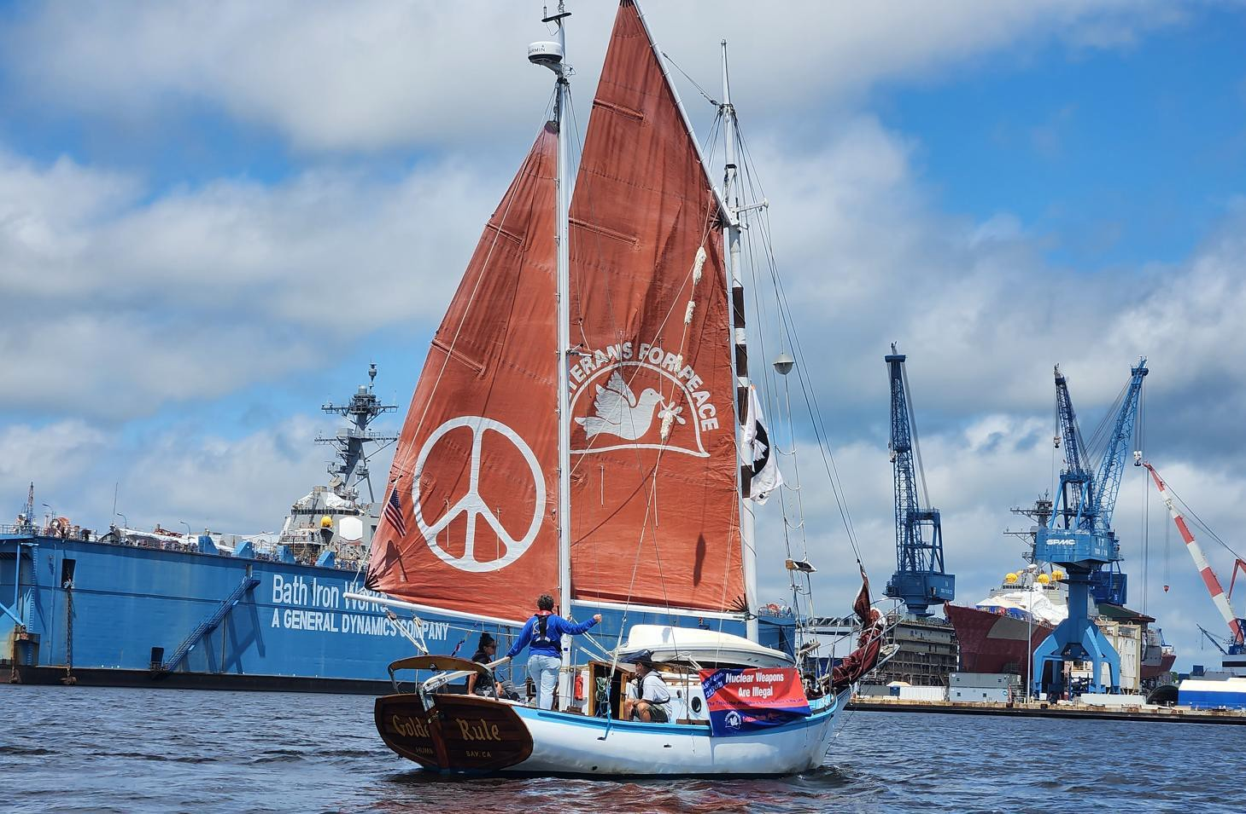
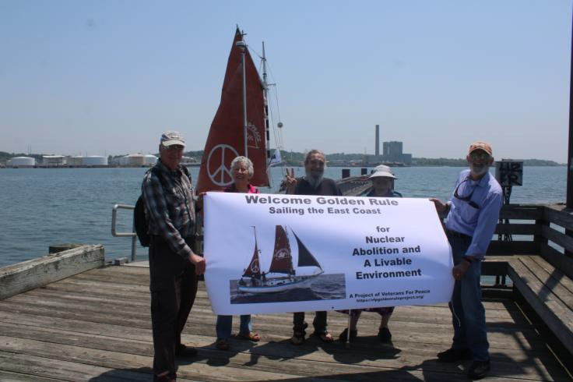
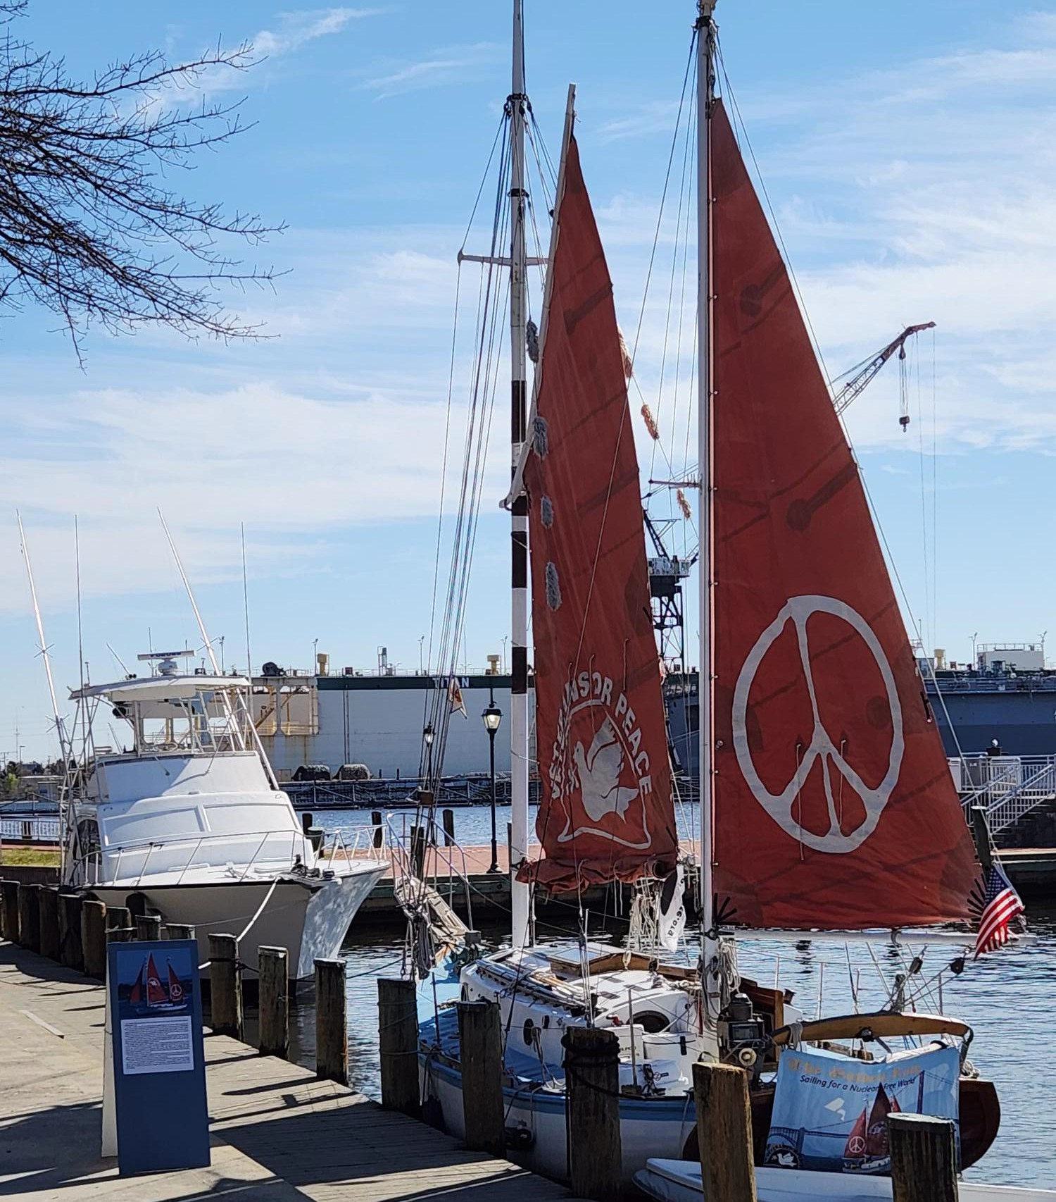
Norfolk, Virginia - home to all branches of the military The Golden Rule with a huge navy ship in the background
The ship of peace sails in protest of Bath Iron Works, makers of nuclear-capable war ships

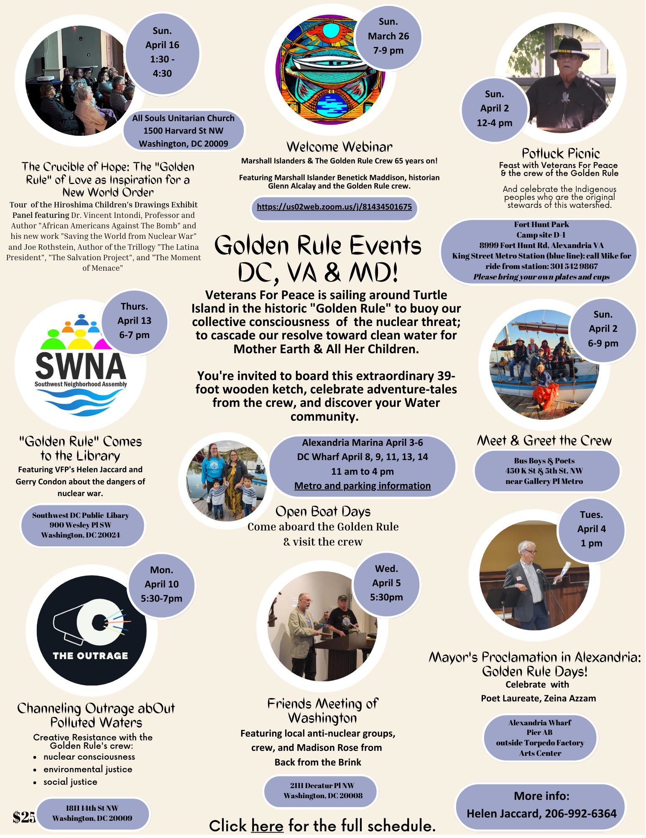
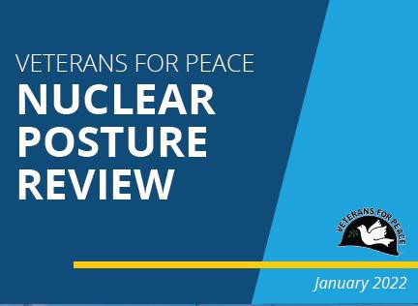
Alexandria, VA and Washington, DC March 26 - April 16
On April 12 & 13 Golden Rule crew and representatives walked the halls of Congress!
Every member of Congress and the Senate received a VFP Nuclear Posture Review!

Potomac River, Piscataway Creek, Chesapeake Bay - Military Poisons tour

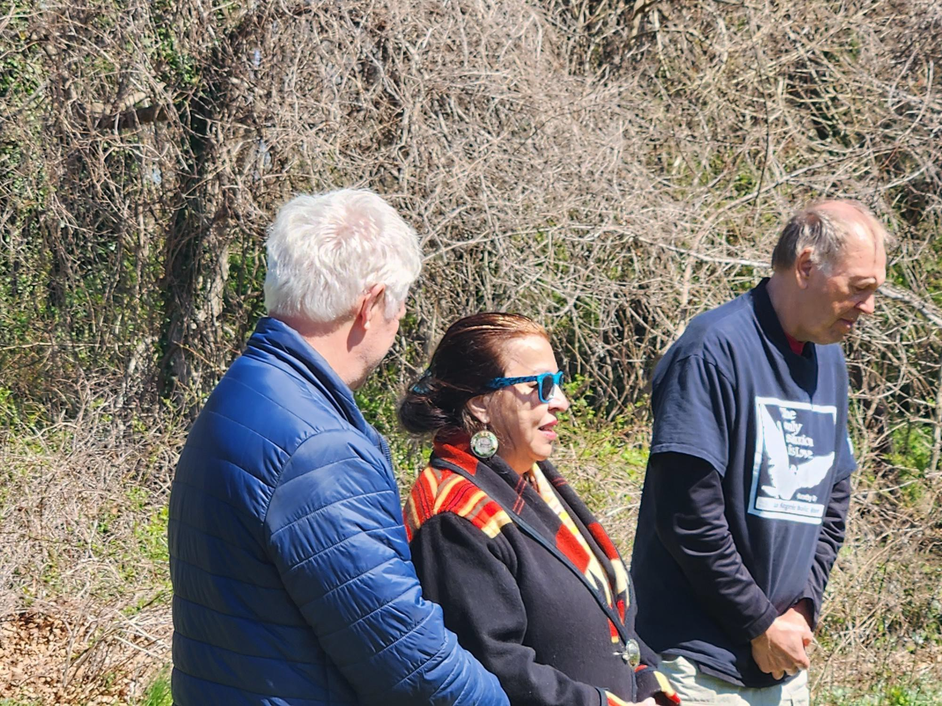
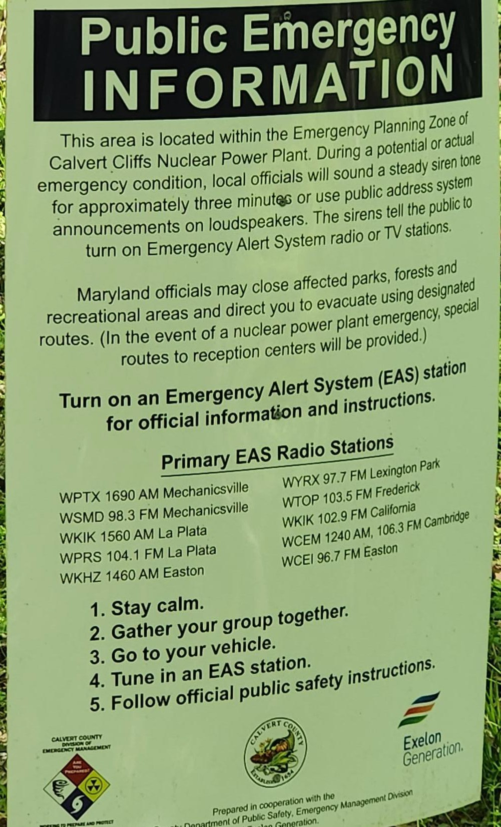
- Julie Tayak Yates talks about the poisoning of her ancestral lands by the US military
The Golden Rule sailed past the Calvert Cliffs NPP, just 3 miles from an LNG export facility

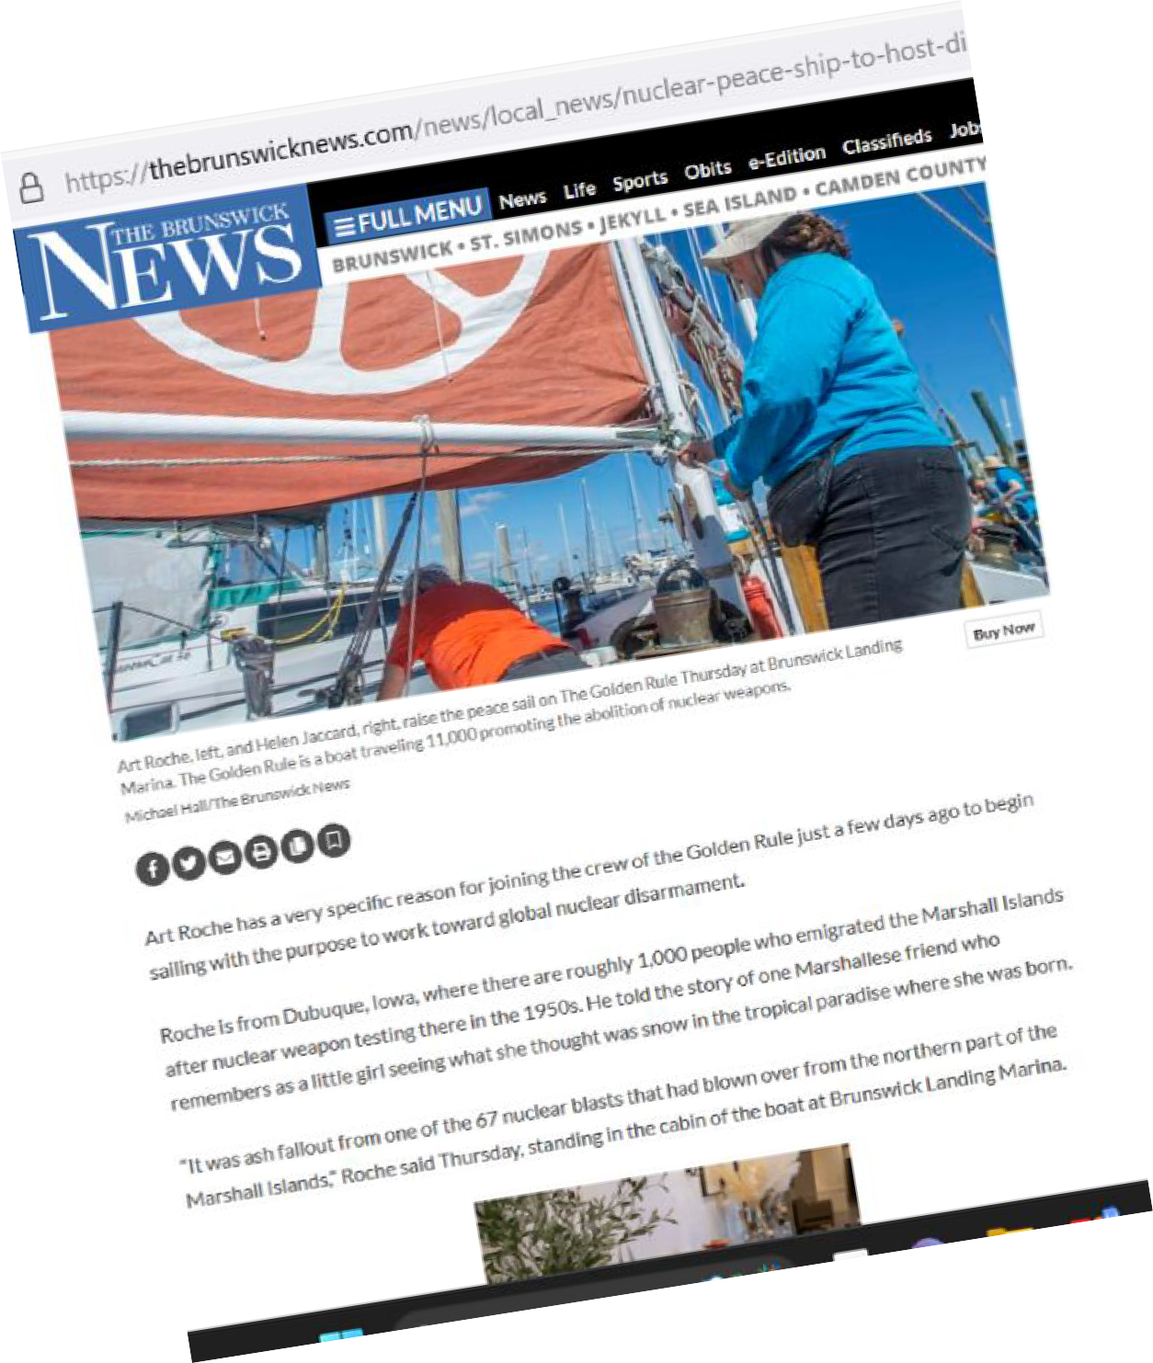
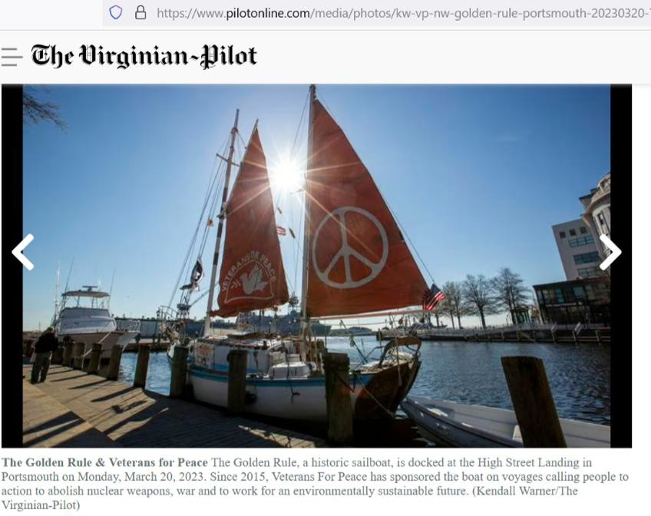
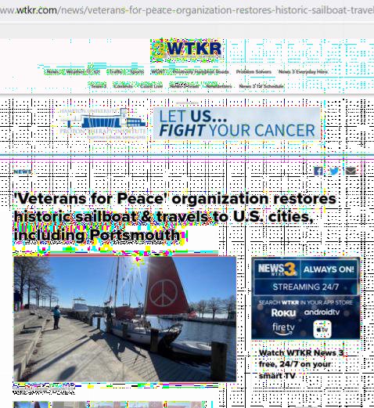
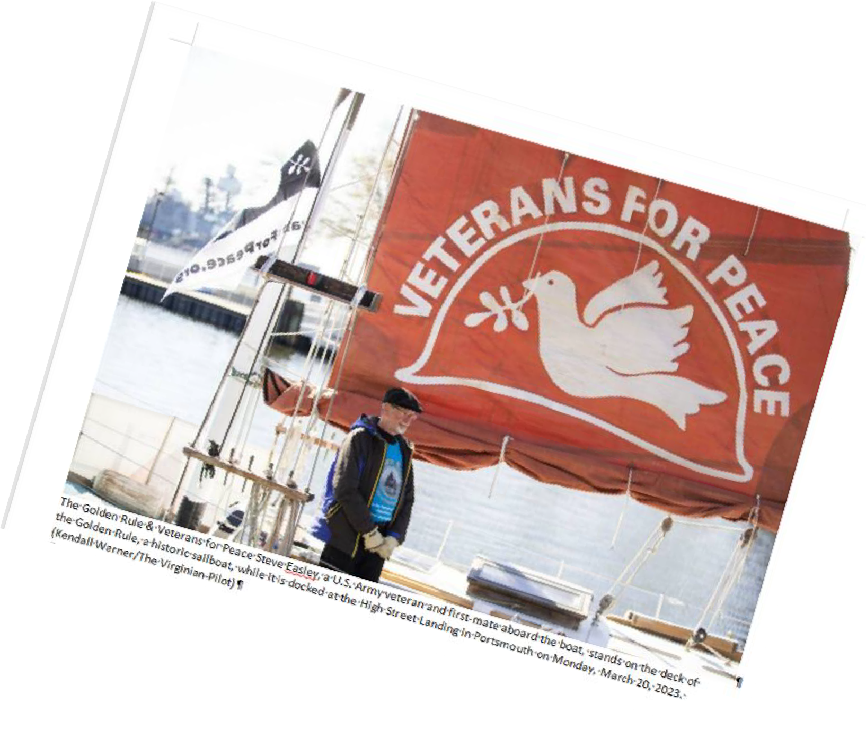
Media Coverage - EVERYWHERE!

Baltimore Sun, Philadelphia Inquirer!
Medium | Count
Paper | 40
TV | 22
eNews | 21
Radio | 7
Magazine | 4
Blog | 1
Podcast | 1
Radio, YouTube | 1
Total # Articles | 97

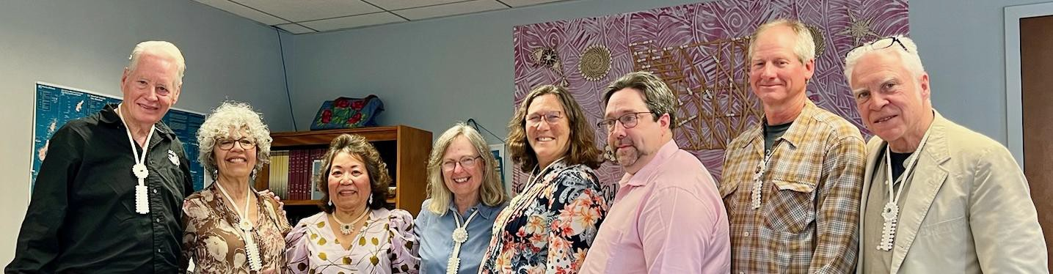
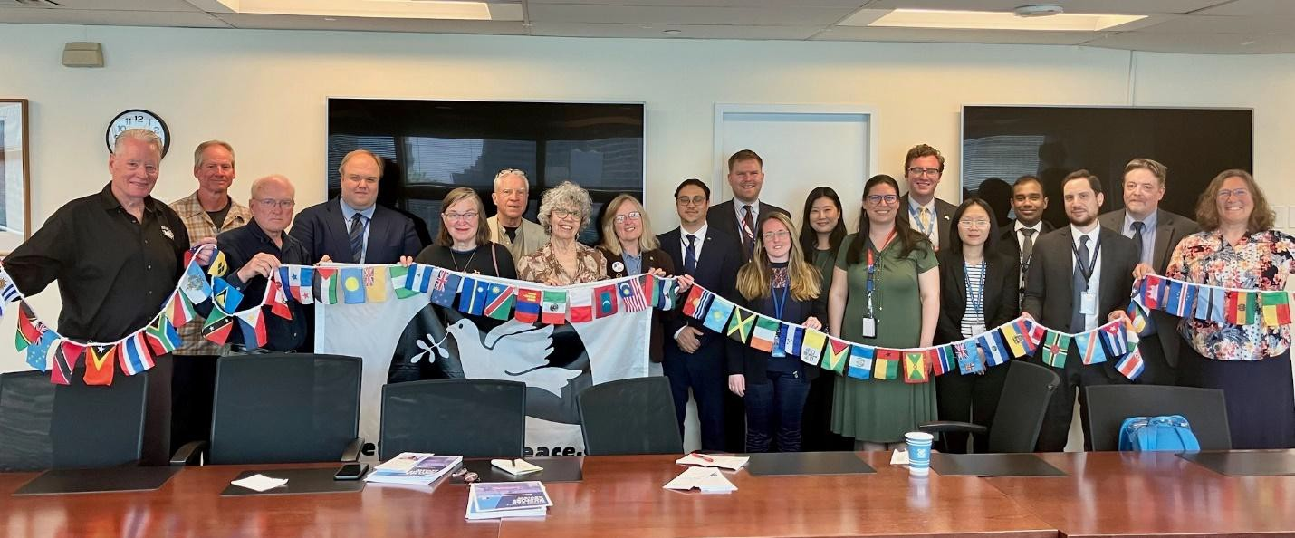
United Nations Missions!

Veterans For Peace and the Golden Rule team met with twelve UN missions, including New Zealand, Malaysia, Vietnam, Cuba, South Africa, Austria, Indonesia, Ireland, Costa Rica, Kiribati, and the Vatican

Veterans For Peace delegation visited with the Permanent UN Representative from the Republic of the Marshall Islands. Ambassador Amatlain Elizabeth Kabua gave a very warm welcome in her cozy UN office and spoke with the group for over two hours.

Rhode Island: Providence, Bristol

(l-r) Golden Rule crew members Steve Baggerly, River Pember, Bristol Town Councilman Aaron Ley, crew member Bill Good and Councilman Tim Sweeney pose with a doctrine that states Bristol is in favor of a ban on nuclear weapons.
Golden Rule crew are greeted by members of the Pokanoket tribe.

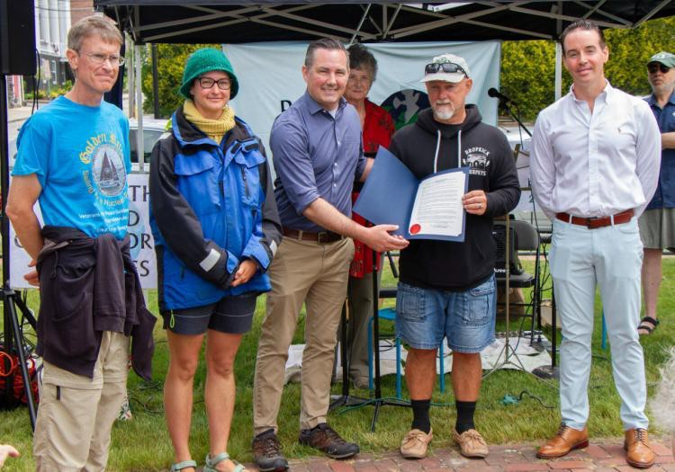
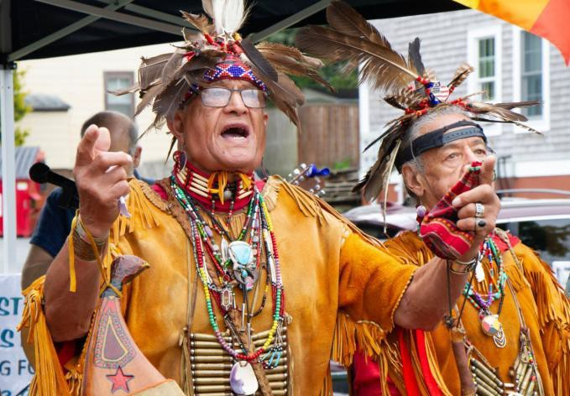
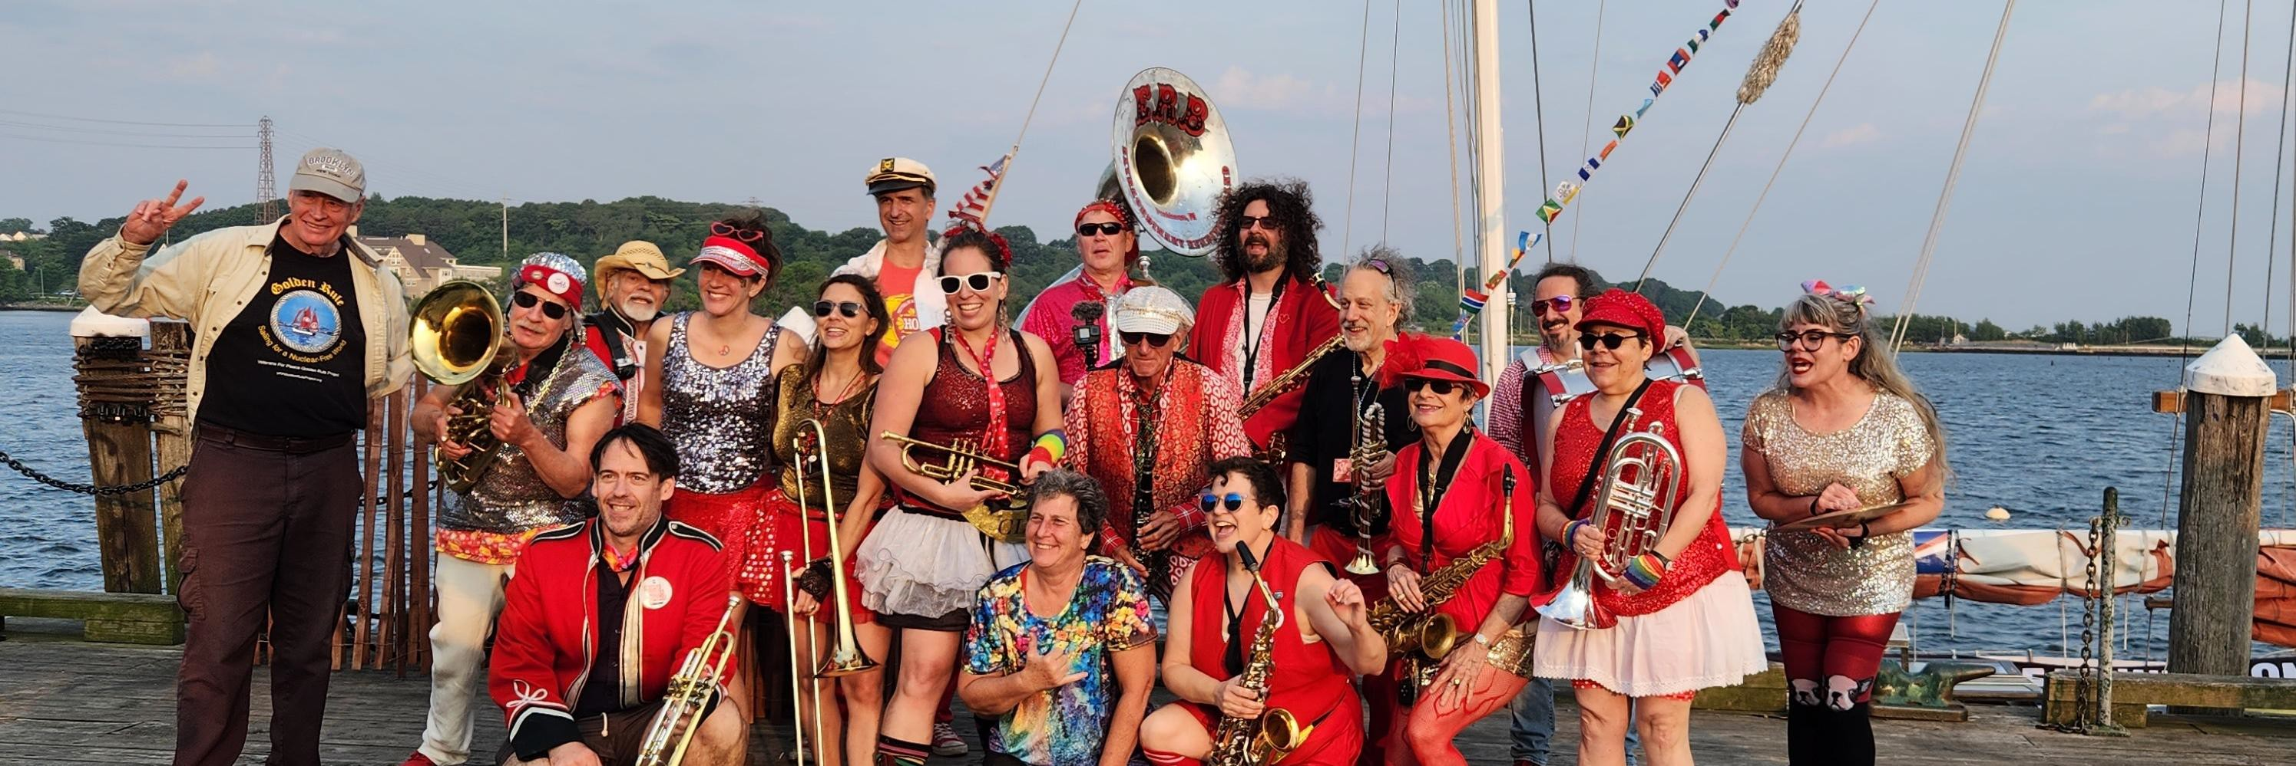
The Extraordinary Rendition Band played rousing music on the dock!

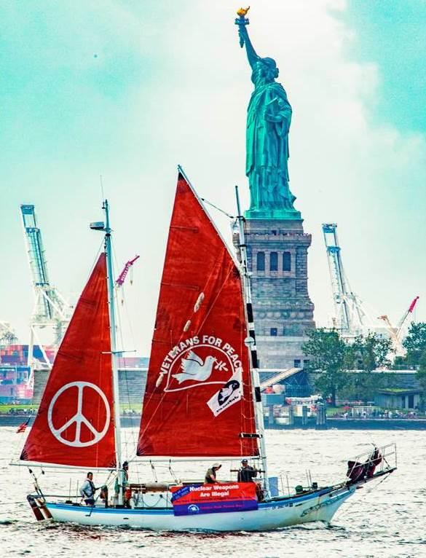

The Great Lakes 2023 Veterans for Peace (i,oldent'Ruk sail route for nuckar-fre,e, world
w

Blind River Uranium Refinery
Mackinaw City
8/20-21
200 million tonnes of radioactive uranium
mine tailings in the Serpent River Watershed
KEY
{j STOPS/ACT ITIES
Nuclear Hot spots
Golden Rule Sail Route
£w-i2 aw== .....
Reactor Closed/Buried

Kewaunee Nuclear Reactor Nuclear Waste
Point Beach
2 Nuclear Reactors Nuclear Waste ,

Big Rock Point
A Nuclear Waste
W Contamination
Traverse City
8/22-24
Canada

Sheboygan
8/25-29
Milwaukee A
8/30-9/5 W.

Racine
9/5-7
Dates May Change!
Please Check vfpgoldenruleproject.org
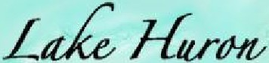
& Helen Jaccard ph# 206-992-6364
for current information
Ml,ch{,gaw
lowerP
Lansing 8/15
A Port Huron 8/17 Kalamazoo W Ann Arbor Detroit Teach In 9/11 8114 8113_17
*
{J

8 Bruce Nuclear Reactors Nuclear Wast
Incinerator O
Centralized Nuclear Waste Storage Proposed Mega Nuclear Dump
Canadi,an;

Palisad{esJNuclear PP

Fermi1&2
l HurOYII Water

Chicago Area Nuclear Labs
Nuclear Reactors Chicago
Nuclear Waste 9/13- 18
Buried Nuclear Reactors
Shut Down-Reopen? Operating Nuclear Reactor Nuclear Waste Nuclear Waste
St.Joseph 9/7-12
DC Cook 1 & 2

Operating Reactors
Nuclear Waste

I�
Toledo 8/10-13 Davis-Besse Operating Reactor Nuclear Waste

Sandusky Cleveland
8/8-10 8/5-8 Perry NPP
Operating Nuclear Reactor
Ohu:r Nuclear Waste, Relicensing
vfp golden rule brochure v.5 © 2023

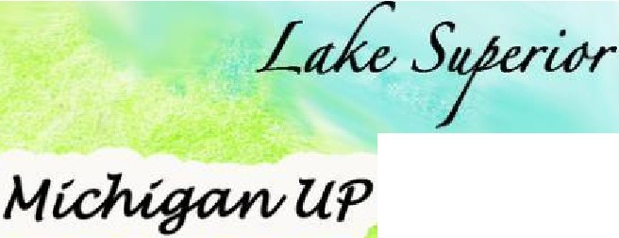
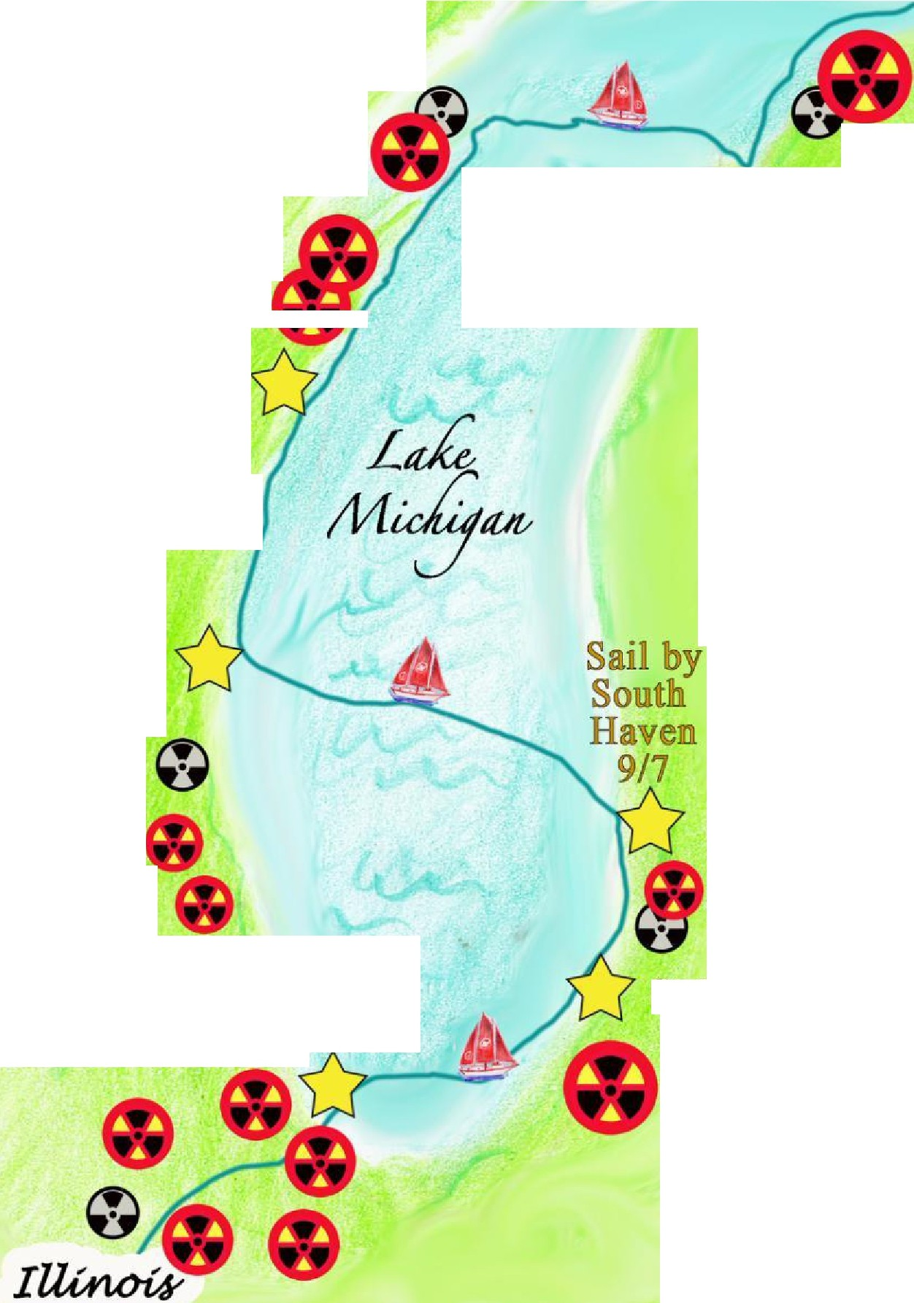
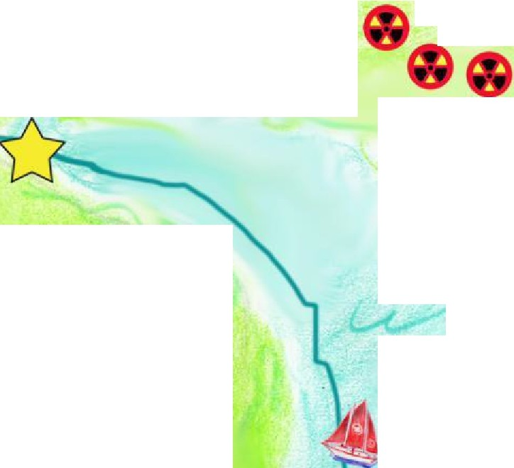
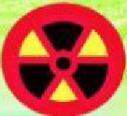
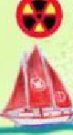
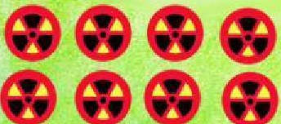
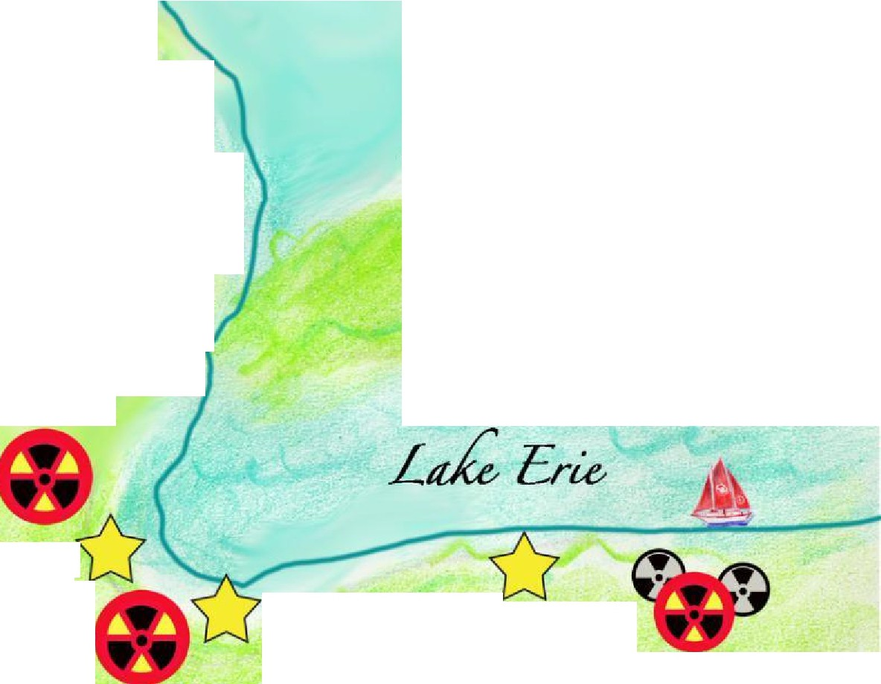
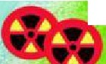

Great Looop Voyage Co-Sponsored by:
CodePink Women for Peace Back from the Brink
World BEYOND War RootsAction
Earth Quaker Action Team
Women’s International League for Peace & Freedom NuclearBan.US
United for Peace & Justice
And supported by many local chapters of: Physicians for Social Responsibility Raging Grannies
Quakers
Unitarian Universalists Catholic Workers

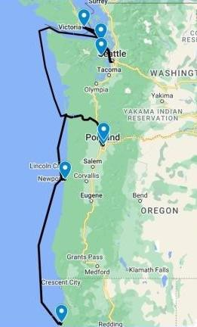
2024 Sailing Plan (Preliminary) to Pacific Northwest

Mon 7/15 Eureka, CA

Departure Press Conference
Sat 7/27 – Sat 7/27 Bangor, WA

Protest Nuclear Submarines
Mon 7/29 – Mon 8/29 Puget Sound

8/6-11 Fleet Week in Seattle
Fri 8/30 – Wed 9/04 Victoria, BC

Victoria Classic Boat Festival
Fri 9/06 – Sun 9/08 Port Townsend, WA

Port Townsend Wooden Boat Festival
Fri 9/13 – Wed 9/18 Vancouver, WA & Portland, OR

9/14 Vancouver Peace Fair
Mon 9/30 Eureka, CA
Welcome Home Party, Press Conference

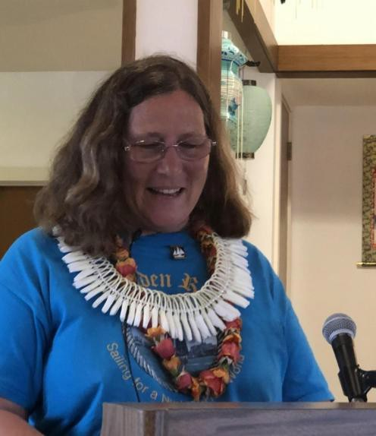
Program: 200 Presentations

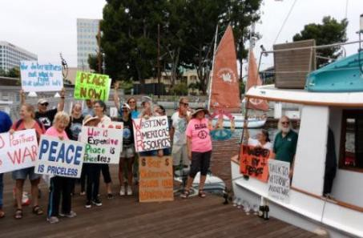
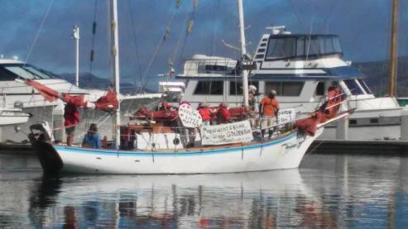
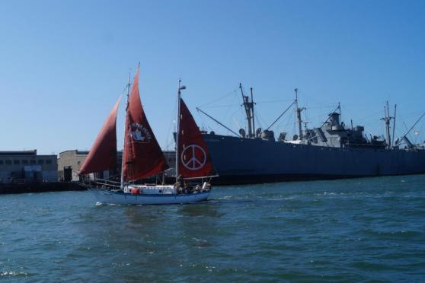
Program: Fleet Week Protests
Bringing a message of Peace in contrast to the Machines of War, Inspiring Activists! Fleet Week in Seattle, Portland, San Francisco, Los Angeles, San Diego

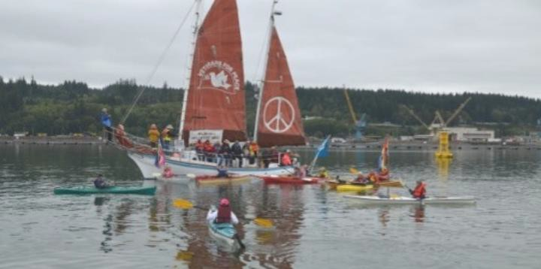
Program: Protest at
Nuclear-Armed Submarine Base
First water-based protest since 1982 was with Golden Rule in 2016

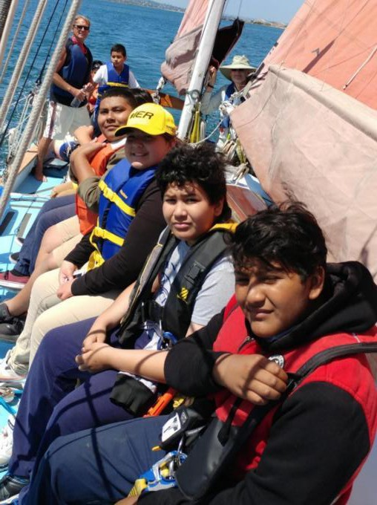
Program:
Day Sails

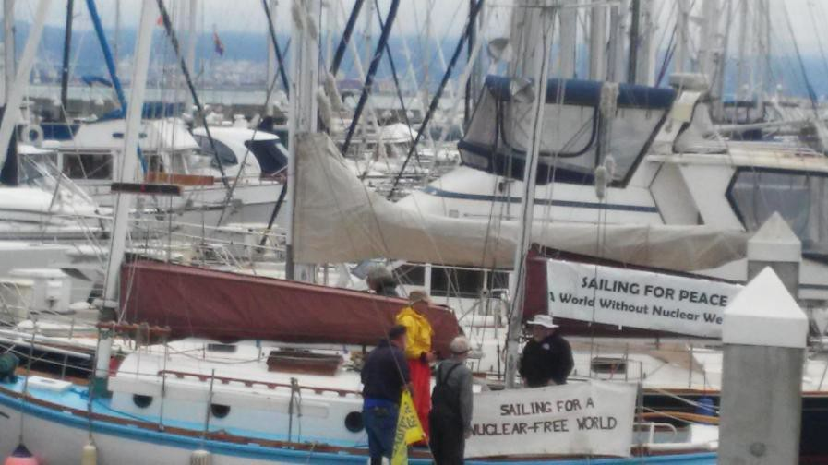
Program: Boat tours

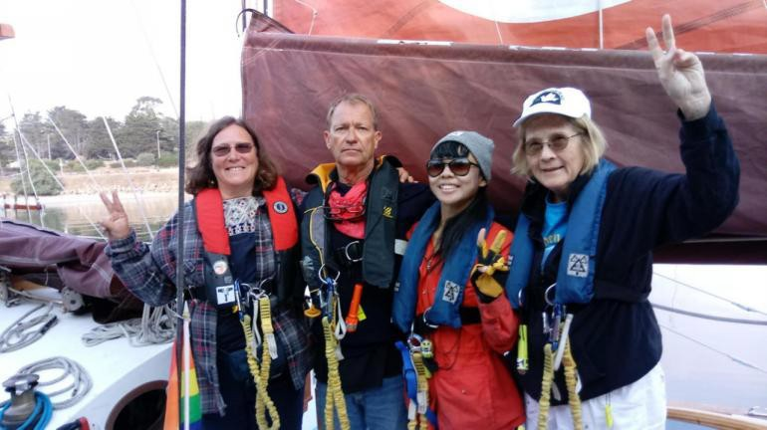
Program: Guest Crew

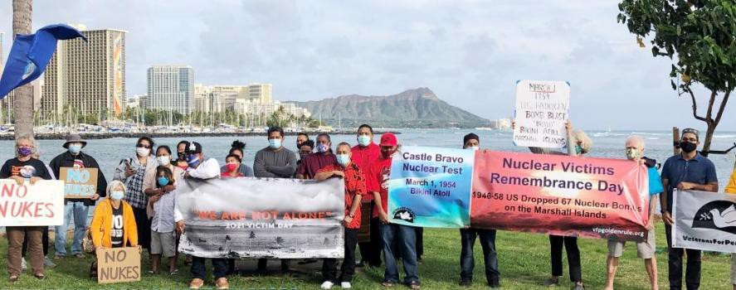
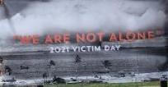
Solidarity with Marshall Islanders

The Golden Rule
A Weapon of Mass Education
- Past nuclear weapons tests, use,
lasting effects on people and environment
- Nuclear weapons are already used in war through threat of use
- Effects of a nuclear war
- Current dangers
- Actions
  - UN Treaty on the Prohibition of Nuclear Weapons and other treaties
  - Bills before Congress
  - VFP No Nukes Working Group and Nuclear Posture Review
- Organizations (mentioned as Great Loop sponsors above)

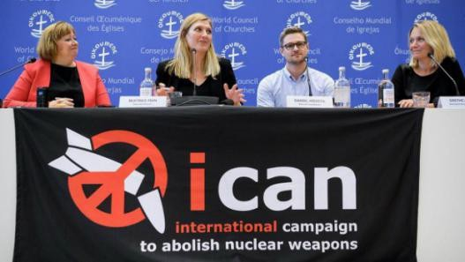
The 2017 Nobel Peace Prize was awarded to the
International Campaign to Abolitish Nuclear Weapons (ICAN) for its work to support the UN Treaty on the Prohibition of Nuclear Weapons (TPNW).

Veterans For Peace and the Golden Rule Project are members of ICAN

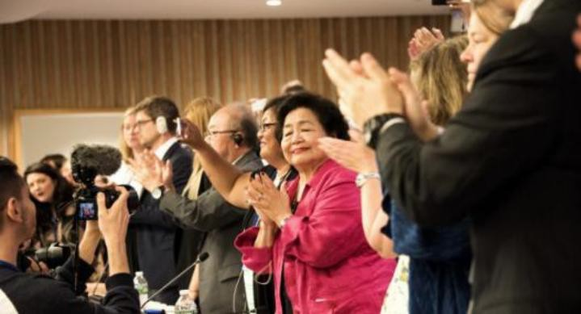
On July 7, 2017 the United Nations overwhelmingly passed the historic UN Treaty on the Prohibition of Nuclear Weapons. Approved by 122 countries - the UN Treaty makes it illegal to possess, use, deploy, transfer or threaten to use nuclear weapons.

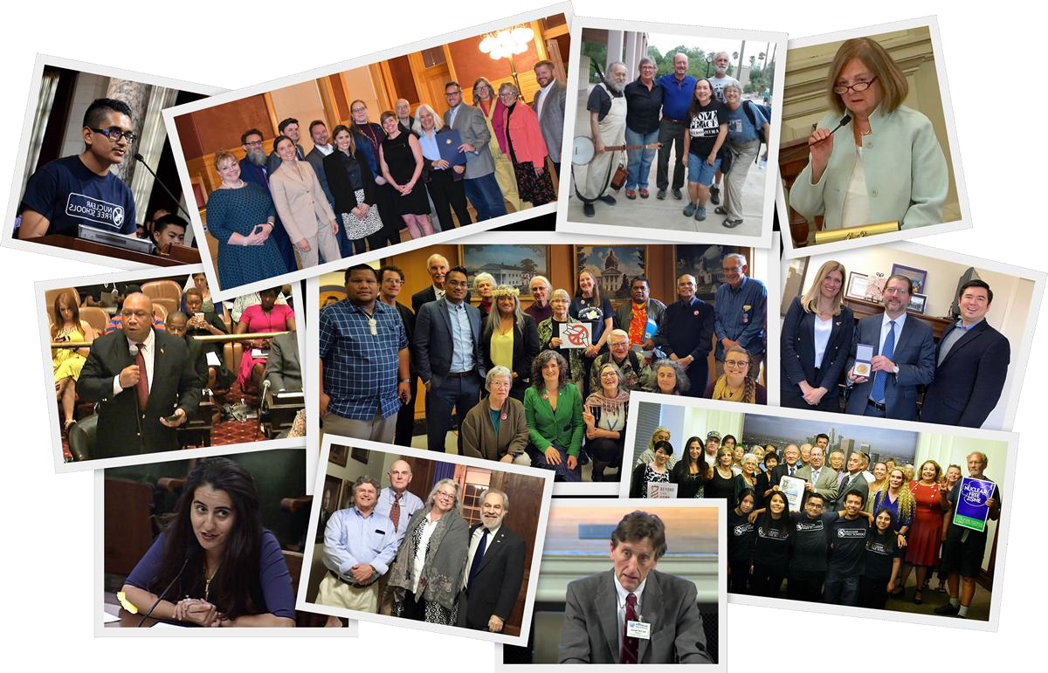
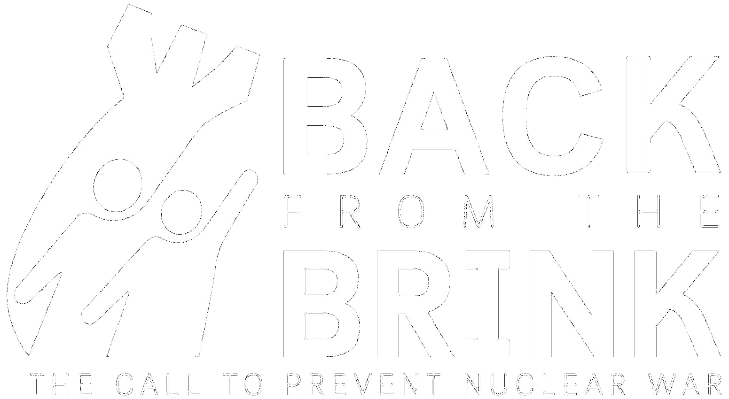
Organizing Locally To Prevent Nuclear War

A PRESENTATION FOR COMMUNITIES

WE CALL ON THE UNITED STATES TO LEAD A GLOBAL EFFORT TO PREVENT NUCLEAR WAR.

PURSUE GLOBAL ELIMINATION

END SOLE PRESIDENTIAL AUTHORITY

END HAIR-TRIGGER ALERT

CANCEL ENHANCED WEAPONS

RENOUNCE FIRST USE

TAKE ACTION

- Engage on social media
- Urge your elected officials to endorse the campaign
- Spread the word via local media (letters, Op Eds, radio)
- Work with other groups and leaders in your community
- Pass a resolution in your local government

Take Action!
VFP Nuclear Posture Review: www.tinyurl.com/VFP-NPR
- share it widely, and use it as a tool in your own anti-nuclear activities.
  - The Nuclear Ban Treaty Collective has resources to help with your actions, including banners. nuclearban.us
  - If you are participating in MLK events, highlight his opposition to nuclear weapons!
  - Ask your Congressional Representatives to support federal legislation to:
    - Embrace the Goals and Provisions of the TPNW, H. Res. 77
    - Maintain Congress’ constitutional authority to declare war or a nuclear strike, H.R. 669
    - Redirect military spending to meet human needs, H.R. 1134
    - Redirect nuclear weapons spending to clean energy and human needs, H.R. 2775

- As your member of Congress to join the Parliamentary Pledge of the International Campaign to Abolish Nuclear Weapons
(ICAN) https://pledge.icanw.org/.
- Enroll your City or State in the ICAN Cities Campaign. https://cities.icanw.org/ and Mayors For Peace.

