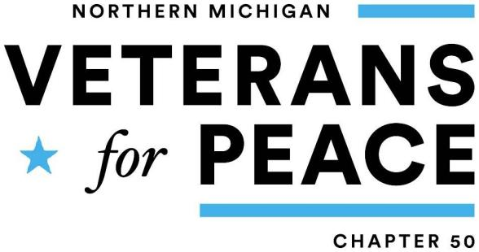
For Immediate Release: August 1, 2023
Contact:
Helen Jaccard, Golden Rule Project Manager
vfpgoldenruleproject@gmail.com or 206-992-6364

or Tim Keenan, President, Veterans for Peace, Chapter 50
231 357-4776 or timkeenan1946@gmail.com
Golden Rule Peace Boat Coming to Traverse City
Historic Sailboat Supports UN Treaty to Ban Nuclear Weapons
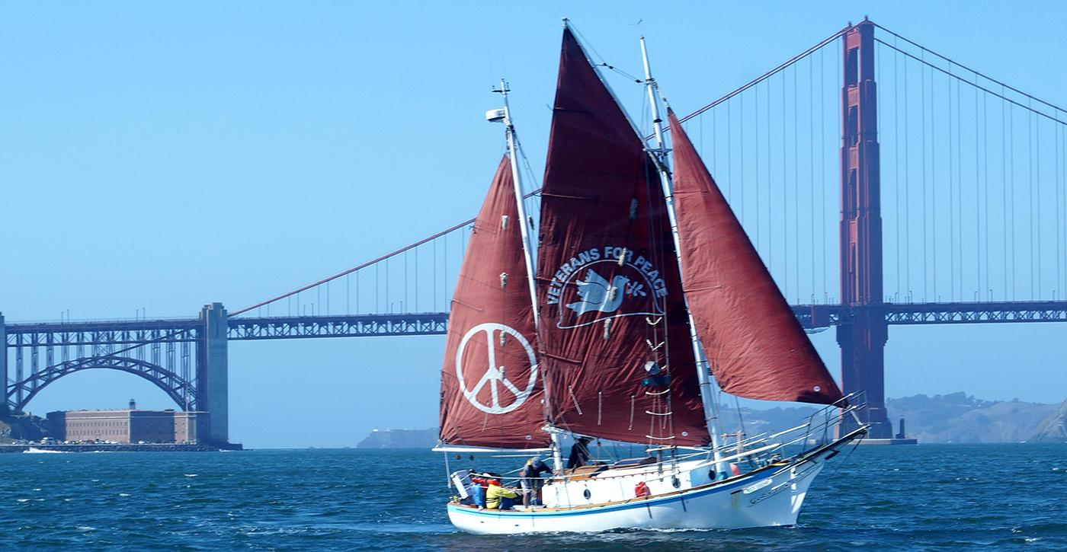
Veterans for Peace of Northern Michigan will welcome the Golden Rule and its mission of peace to Traverse City on Tuesday, August 22 & Wednesday, August 23, 2023.
The Veterans for Peace (VFP) Golden Rule first set sail to oppose nuclear weapons testing in 1958. The visit of the 34-foot wooden ketch to Traverse City is an opportunity for our community to turn out stand against the modern threat of nuclear war and welcome the historic vessel as she sails into Grand Traverse Bay past Northport, Omena, Peshawbestown, Suttons Bay, and Old Mission to Traverse City’s Open Space Park.
The visit of the Golden Rule comes at a moment when we once again face the global threat of nuclear war. To raise awareness and to build support for the abolition of nuclear weapons, Veterans for Peace is hosting a series of events and sending out the call for local boats to meet and escort the Golden Rule as she sails down Grand Traverse Bay in a triumphant Flotilla for Peace. To get involved, sign up at https://leelanau.com/goldenrule
"There is so much divisiveness in our world and community today,” explains Tim Keenan, President of Veterans for Peace, Chapter 50. “One fact the vast majority of us can agree on is that the use of nuclear weapons would be catastrophic for humankind and our planet. The Golden Rule aims to bring awareness of the importance of supporting the UN treaty to ban nuclear weapons, and the visit gives the people of our region a chance to make their voices heard."
In the evening on Tuesday, August 22 the State Theatre will host a free showing of two 25-minute documentaries: Making Waves: The Rebirth of the Golden Rule followed by Phoenix of Hiroshima: An Odyssey Interrupted and a Q&A with the crew of the Golden Rule. Movies begin at 7:00pm, doors open at 6:30pm.
On Wednesday, August 23, the public is invited to the Open Space at Clinch Park Marina to learn about nuclear issues today and how we can stop the possibility of nuclear war.
From 11am - 3pm, the crew and captain of the Golden Rule will host educational boat tours that bring to life the history and mission of the Golden Rule Project and provide an intimate look at how just a few people can make a difference.
That calm fortitude continues as Veterans for Peace of Northern Michigan hosts a Peace Rally at 4:30pm. The rally will be opened by tribal drummers and singers, followed by speakers and musicians including:
- Helen Jaccard, Golden Rule Project Director
- Gerry Condon, Golden Rule crew member
- Alfred Meyer, Physicians for Social Responsibility lobbyist, writer on nuclear issues, Part-time crew member
- John Zachman, NMC professor
- Holly Bird, Water Protector and co-executive director of Title Track
- Kevin Kamps, Beyond Nuclear watchdog and nuclear waste specialist
- Grand Traverse Band Community Drum
- Mindimooyenh Healing Circle, Indigenous women honoring the water with song
- Victor McManemy, musician and activist
- Robin Lee Berry, musician and curator of peaceful vibes
To view a complete schedule of events, information about speakers, presentation, and the Golden Rule including live updates on the current location of the vessel and organization of the Flotilla for Peace, please visit https://leelanau.com/goldenrule.
To schedule an interview, please contact the Golden Rule Project Manager, Helen Jaccard,at vfpgoldenruleproject@gmail.com or 206-992-6364 or Tim Keenan, President of local chapter 50, Veterans for Peace, 231 357-4776 or timkeenan1946@gmail.com.
Link to media images for download (click link to preview image):
The Golden Rule in front of the Golden Gate Bridge in San Francisco, Calif., at the end of its first sailing season since the re-build, October 2015. Photo by Gerry Condon.
Golden Rule Shines in San Francisco Photo by Norman DeVall, Nadya Williams and Gerry Condon
SV Golden Rule in TenTom Waterway 2022

