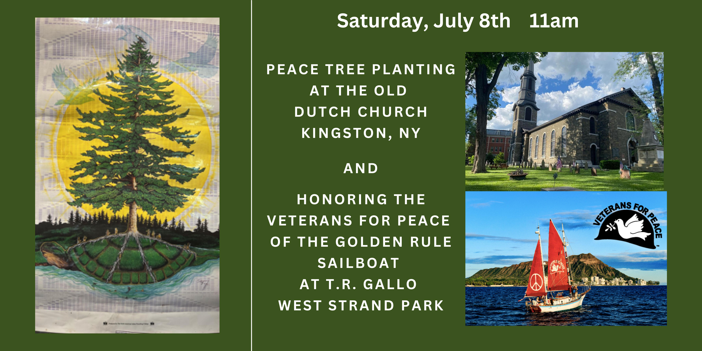

The Esopus Wars were two conflicts between the Esopus tribe of Lunaape (Delaware) and New Netherlander (Dutch) colonists during the latter half of the 17th century in Ulster County, New York. The wars started when a Dutch farmer shot and killed two local indigenous women who were picking apples from a tree.

We will gather on Saturday, July 8th for two ceremonies facilitated by Rev. Liz Estes and Mr. Rob Sweeny of The Old Dutch Church, and Turtle Clan Chief Vincent Mann of the Ramapough Munsee Lunaape Nation.

First at the Old Dutch Church (272 Wall St, Kingston, NY 12401) meet at 11AM for a Peace Tree Planting. This tree will be a crab apple tree, a Turtle Island native variety that can cross-pollinate with the apple tree of European ancestry that was planted at the Church on the Summer Solstice 2023. Light refreshments to follow. https://olddutchchurch.org/

Next we will proceed to T.R. Gallo West Strand Park (1 Broadway Kingston NY) for a ceremonial gift exchange and celebration with Captain Kiko Johnston-Kitazawa (of Hawaiian ancestry) of The Golden Rule sailboat, which is crewed by Veterans for Peace. Back in 1958, The Golden Rule was the very first of the environmental and peace vessels to go to sea.
Learn more about them at https://vfpgoldenruleproject.org/
Invite friends to the Facebook Event: https://www.facebook.com/events/602914631964570/?ti=ls
Aloha, Kuwiinguneewulohmwa (Kah-wing-ah- neh-wool low-mwah)
We would be glad to see you all!

