FOR IMMEDIATE RELEASE Contact: Gerry Condon, 206-499-1220
January 17, 2023 Helen Jaccard, 206-992-6364
US Veterans Sail Historic Peace Boat to Cuba
Anti-Nuclear Sailboat Returns from Havana to Miami
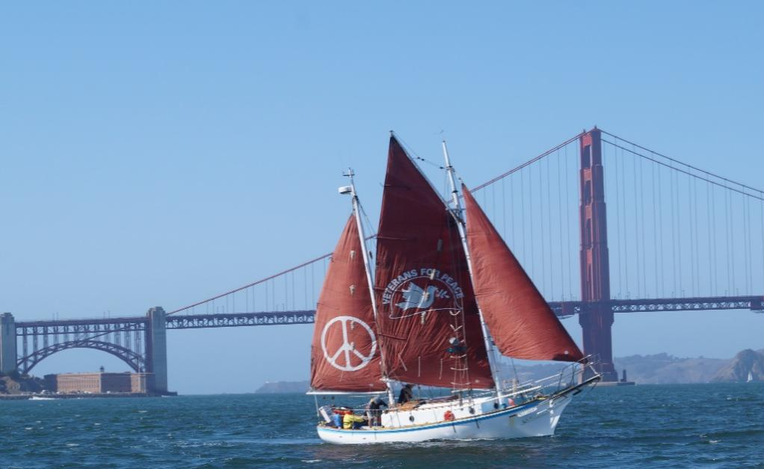
The Golden Rule Peace Boat at the Golden Gate Bridge
The historic Golden Rule anti-nuclear sailboat is in Miami harbor after completing a momentous voyage to Cuba. The 34-foot wooden ketch, which was sailed toward the Marshall Islands in 1958 to interfere with US nuclear testing, belongs to Veterans For Peace, and carries out its mission, “to end the arms race and to reduce and eventually eliminate nuclear weapons.”
“We are on an educational mission,” says Golden Rule Project Manager Helen Jaccard. “We are four months into a 15-month, 11,000 mile voyage around the “Great Loop.”
“We saw we would be in Key West at the end of December, and we said, ‘Hey, look, Cuba is only 90 miles away!’” said Helen Jaccard. “And the world almost had a nuclear war over Cuba.”
Sixty years ago, in 1962, the world came perilously close to a civilization-ending nuclear war during what became known as the “Cuban Missile Crisis.” How did that happen? Many of us will remember that the Kennedy administration discovered that the Soviet Union had placed nuclear missiles in Cuba, within easy striking distance of U.S. cities. This was of course unacceptable, but it was a response to the US placing nuclear missiles in Turkey near the USSR. And the CIA had recently organized the “Bay of Pigs” invasion, a failed attempt to overthrow the government of Fidel Castro. President Kennedy ordered a naval blockade of Cuba, leading to a nuclear standoff with the USSR. Kennedy and Soviet premier Nikita Krushchev then successfully negotiated to avoid a nuclear war that neither man wanted.
“Without the US hostility to an independent, socialist Cuba, we would not have come so close to nuclear war in 1962,” says Gerry Condon, former president of Veterans For Peace and part of the crew who sailed to Cuba. “There are a lot of lessons to learn from the Cuban Missile Crisis. But have they been learned? The US seem to be making the same mistakes in Ukraine today. This time it is the US that has moved hostile military forces, including nuclear weapons systems, close to Russia’s borders.”
For many years Veterans For Peace has been calling for an end to the US blockade of Cuba. Now some in the US are calling for at least a temporary suspension of the blockade, to allow Cuba to rebuild after Hurricane Ian, which destroyed as many as 10,000 homes in the western province of Pinar del Rio.
“We carried humanitarian aid and delivered it to Pinar del Rio,” said Gerry Condon. “We also witnessed the economic suffering that is being caused by the cruel 60-year US blockade of Cuba, and we will now be telling people about this wherever the Golden Rule sails.
“When people learn about the suffering that the US government is causing normal Cuban citizens, they will join Veterans For Peace in calling for the US blockade to finally end.”
Six people, including several members of Veterans For Peace, sailed the Golden Rule to Cuba and arrived in Miami last Thursday morning. The Golden Rule is moored out at the Dinner Key Marina in Miami, where it will remain through Saturday, January 21. It can be viewed by making a prior arrangement at 206-992-6364.
The historic Golden Rule anti-nuclear sailboat will then proceed to Fort Lauderdale, West Palm Beach and Jacksonville, among other Florida stops. See schedule here.
The Golden Rule sailed to Havana under a General License issued by the US Treasury Dept. that allows US residents to travel to Cuba for educational and people-to-people purposes.
To arrange interviews or visits to the Golden Rule peace boat, please call 206-992-6364.
www.vfpgoldenrule.org

