The Golden Rule:
“Sailing for a Nuclear-free World and a Peaceful, Sustainable future.”
A project of Veterans for Peace
Wed., Oct. 12, 7 pm, NW Community Center, 5110 Franklin Ave. DSM. 50310
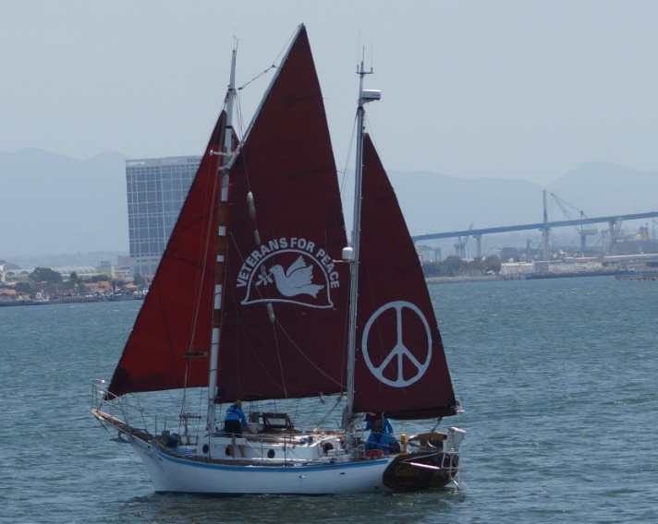

The VFP Golden Rule Sails For:
- US Ratification of the Treaty to Prohibit Nuclear Weapons (TPNW)
- Commitment to No First Strike
- Taking weapons off “hair-trigger” alert
- Transferring the nuclear weapons cost into human needs

The Golden Rule has a proud history and now VFP is bringing it back into service. In 1958 Quakers sailed the Golden Rule to the Marshall Islands to demand the US stop nuclear weapons testing on the islands. Today VFP is sailing to build public support for the abolition of nuclear weapons.
VFP crew members will highlight the growing threats and will offer tools to help us mobilize.

“… A nuclear peace is possible, and bravery and tenacity can overcome militarism.”
--VFP website
Sponsored by Catholic Peace Ministry; Co-sponsors: Veterans for Peace, Women’s International League for Peace & Freedom-Iowa Chapter, Iowa Peace Network, Ames Friends Meeting, DM Faith Committee for Peace, Methodist Federation for Social Action-Iowa, Downtown Disciples: A Progressive Faith Community, American Friends Service Committee-Midwest Region, DM Valley Friends Meeting, Des Moines Intentional Eucharistic Community Social Justice Committee, Sisters of Humility Des Moines, First United Methodist Church Outreach Committee, Plymouth Peace & Justice Committee

For more information: catholicpeaceministry@gmail.com

