Draft article and press release

Golden Rule peace boat returning to San Diego!

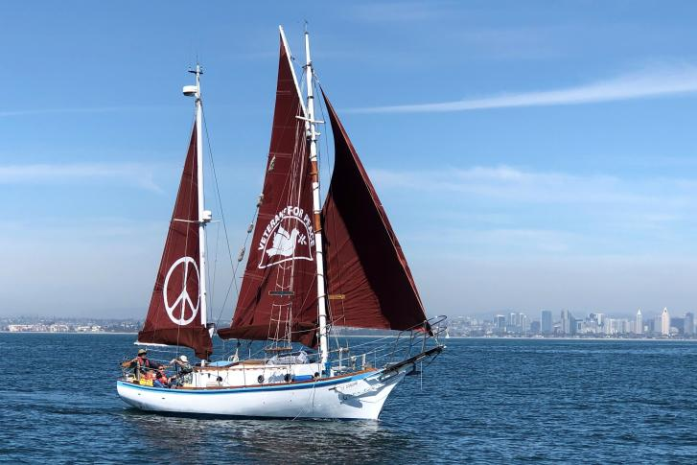
The Golden Rule, a Project of Veterans For Peace, sailed from San Diego to Hilo, Hawaii in May 2019.

The Project’s intention was to spend a few months in Hawaii, then sail to the Marshall Islands, Guam, Okinawa, and Japan, arriving in Hiroshima 75 years after the nuclear bombings of Hiroshima and Nagasaki. However, Covid shut down access to foreign ports and made in-person presentations impossible. So, as in 1958, when four activists sailed the Golden Rule towards the Marshall Islands to interfere with nuclear bomb tests, the Golden Rule didn’t make it past Hawaii.

During their visit to Hawaii, the team learned a lot about nuclear contamination and militarism in the Pacific and included representatives from the Marshall Islands, Guam and Okinawa in online presentations.

In June 2021 four very brave crew sailed Golden Rule from Hawaii to San Francisco Bay, taking 30 days for the difficult crossing.

The Golden Rule is in Humboldt Bay in northern California for maintenance and repairs and will be in San Diego County January 14 - February 11. Please tour the boat, come out sailing, or attend an educational presentation! They need crew, speakers, and event organizers. Would you like an educational event at your church / club / school? Contact Helen Jaccard at vfpgoldenruleproject@gmail.com or 206-992-6364 for more information.

Schedule:
Thursday January 13: arrival in Oceanside Harbor, 300 North Coast Hwy, Oceanside, CA 92054
Friday January 14:
(time?) Press Conference
Palomar Unitarian Universalist Church, 1600 Buena Vista Drive, Vista, CA 92081
Outdoor gathering, please wear a mask and observe social distancing guidelines
(time?) Boat tours
(time?) Sailing

Saturday January 15:
9 am: Boat tours
10 am: Sailing
1 pm - 3 pm: Educational presentation
Palomar Unitarian Universalist Church, 1600 Buena Vista Drive, Vista, CA 92081
Sunday January 16:
9 am Boat tours
10 am, 1 pm Sailing
Educational events afternoon and evening - contact Helen Jaccard to schedule your club / church / school event!

Monday January 17:
Transit to San Diego - guests welcome to experience the transit!

Tuesday January 18 - Monday January 24: Shelter Island Harbor Police Dock, 1401 Shelter Island Dr, San Diego, CA 92106

Saturday January 22, 5:30 to 8:00 pm: Educational Presentation
Church of the Brethren, 3850 Westgate Pl, San Diego, CA 92105
First Anniversary of the UN Treaty on the Prohibition of Nuclear Weapons Entry into Force
Lasagna (meat and vegetarian options), salad, garlic bread
Suggested donation $30 (no one turned away for lack of funds), includes two beverages
Capacity is limited, please RSVP if possible to vfpgoldenruleproject@gmail.com.
Please wear a mask and sit with people you are usually exposed to.

Daily January 18 - January 24:
9 am Boat Tours
10 am and 1 pm Sailing
Educational events afternoon and evening - contact Helen Jaccard to schedule your club / church / school event!

Tuesday January 25:
Transit to Chula Vista - guests welcome to experience the transit!

Wednesday January 26 - Thursday January 27: Chula Vista Marina, 550 Marina Pkwy, Chula Vista, CA 91910
9 am Boat tours
10 am, 1 pm Sailing
Educational events afternoon and evening - contact Helen Jaccard to schedule your club / church / school event!

Friday, January 28:
Transit to Ensenada, Mexico

Saturday, January 29 - Sunday, January 30: Ensenada Cruiseport Village, Lázaro Cárdenas s/n, Zona Centro, 22800 Ensenada, B.C., Mexico
This is an opportunity for deported veterans and their supporters to sail on the Golden Rule. There will also be bilingual educational presentations in Ensenada and Tijuana.

Monday, January 31:
Transit to Shelter Island Harbor Police Dock, 1401 Shelter Island Dr, San Diego, CA 92106

Tuesday, February 1 through Sunday, February 6: Shelter Island Harbor Police Dock, 1401 Shelter Island Dr, San Diego, CA 92106
9 am Boat tours
10 am, 1 pm Sailing
Educational events afternoon and evening - contact Helen Jaccard to schedule your club / church / school event!

Saturday, February 5 (time): Educational Presentation
(Name of UU Church, address)

Monday, February 7
Transit to Mission Bay

Tuesday, February 8 through Tuesday February 11
Marina Village Marina, 1936 Quivira Way, San Diego, CA, 92109
9 am Boat tours
10 am, 1 pm Sailing
Educational events afternoon and evening - contact Helen Jaccard to schedule your club / church / school event!

Tuesday, February 11 (time, location tbd): Going away party for Golden Rule and her crew

Background on the Golden Rule peace boat:

In 1958 four Quaker peace activists sailed the Golden Rule toward the Marshall Islands in an attempt to halt atmospheric nuclear weapons testing. The US Coast Guard boarded her in Honolulu and arrested her crew, causing an international outcry.
Rising public awareness of the dangers of radiation led to worldwide demands to stop nuclear testing. In 1963 President Kennedy, the U.S.S.R. and the U.K. signed the Limited Nuclear Test Ban Treaty.
In 2010 the Golden Rule sank in a gale in Humboldt Bay in Northern California. For the next five years, dozens of Veterans For Peace, Quakers and other volunteers restored her in the boat yard of Leroy Zerlang.
The Golden Rule now sails for a nuclear-free world and a peaceful, sustainable future.

From 2015 - 2018 the Golden Rule sailed up and down the West Coast between British Columbia and San Diego. Project Ambassadors gave over one hundred educational presentations and took hundreds of people sailing.
The Golden Rule led “Peace Fleets” in five cities during “Fleet Week”, when the Navy brings its war ships into our ports. Thousands of people visited the Golden Rule during four wooden boat shows.
An Epic Voyage into the Pacific Started, but Stopped by Covid-19
In July 2019 the Golden Rule sailed again to Hawai’i, where there is great concern about a nuclear war between the US and North Korea.
We planned to sail Golden Rule to the Marshall Islands, where the US detonated 67 US nuclear bombs. After stops in Guam and Okinawa, Golden Rule was to sail to Japan for the 75th anniversary of the nuclear bombings of Hiroshima and Nagasaki. However, countries closed their borders and in-person events were unsafe due to Covid 19.
After 22 months, over a hundred presentations, and visiting most of the Hawaiian islands, Golden Rule is now back in California, preparing for the upcoming voyages.

The Golden Rule Great Loop Voyage 2022-2023

Start | End | Stop
 | 9/8/2022 | West Coast
9/9/2022 | 9/14/2022 | Unstep masts, load on trailer
9/15/2022 | 9/21/2022 | Drive to Minneapolis
9/22/2022 | 10/4/2022 | Minneapolis: Step masts, launch, boat tours, sailing, presentations
10/5/2022 | 11/8/2022 | Upper Mississippi: Minnesota, Iowa, Illinois, Missouri (St. Louis)
11/10/2022 | 12/1/2022 | Lower Mississippi: Tennessee (Memphis), Arkansas, Mississippi,  Louisiana (Baton Rouge, New Orleans)
12/2/22 | 2/5/2023 | Alabama (Mobile), Florida (Pensacola, Panama City, Tampa, Miami,  Ft Lauderdale, Jacksonville)
2/6/2023 | 4/3/2023 | Georgia, S Carolina, N Carolina, Virginia
4/4/2023 | 5/18/2023 | Virginia, DC, Maryland, Delaware, Pennsylvania, New York
5/19/2023 | 7/19/2023 | New York, New Jersey, Connecticut, Rhode Island, Massachusetts, Maine  Return to New York, up the Hudson River and through the Erie Canal
7/20/2023 | 9/20/2023 | Great Lakes - Ohio, Wisconsin, Michigan, Illinois
9/21/2023 | 12/1/2023 | Illinois, Mississippi, Ohio, Tennessee, Tombigbee rivers to Mobile, Alabama
PRELIMINARY Schedule

