For Immediate Release Contact: Helen Jaccard, 206-992-6364
September 1, 2019 vfpgoldenruleproject@gmail.com
Web: vfpgoldenrule.org
Facebook: GoldenRulePeaceBoat
Golden Rule Peace Boat coming to Lana’i!
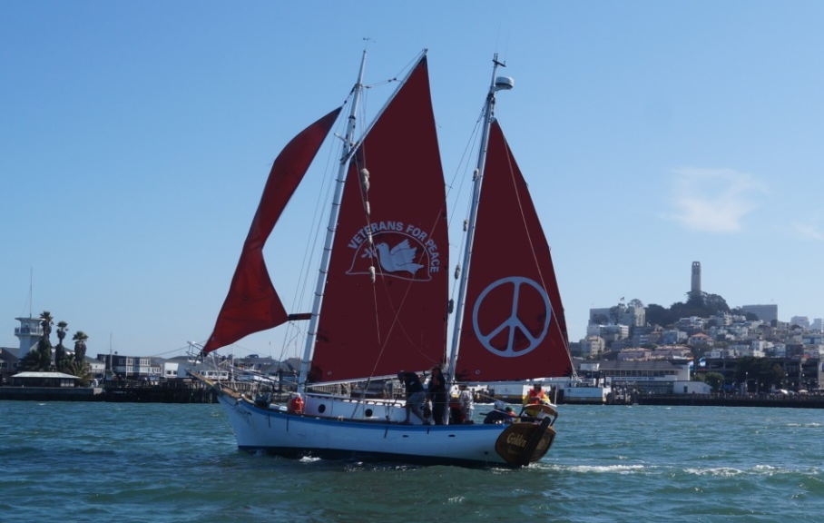
Golden Rule, a Project of Veterans For Peace, will be in Lana’i from October 1 - 8, 2019
Manele Small Boat Harbor
Historic Sailboat Project Supports UN Treaty to Ban Nuclear Weapons
In 1958 four Quakers tried to sail to the Marshall Islands to stop nuclear bomb tests. The boat sank in 2010 and was rebuilt from in Humboldt Bay, Northern California. The Golden Rule is now “Sailing for a Nuclear-Free World and a Peaceful, Sustainable Future”.

After over a year of planning and upgrades, Golden Rule crossed the Pacific Ocean from San Diego to Hilo, Hawaii. The crew will sail all over the Hawaiian Islands, then continue on to the Marshall Islands, Guam, Okinawa, Korea, Japan and more.

The “Peace in the Pacific” voyage is bringing attention to the ongoing effects of nuclear bomb testing in the Pacific, and to the environmental and human impacts of dozens of military bases in the Pacific Islands. The team plans to be in Japan in August 2020 for the 75th anniversary of the nuclear bombings of Hiroshima and Nagasaki.
With tensions so high between nuclear armed nations, it is more important than ever to bring a message of peace into the Pacific.
“The possibility of nuclear war today is all too real,” says Gerry Condon of Veterans For Peace. “It is time to abolish nuclear weapons once and for all. The U.S. can show leadership by being the first nuclear power to sign the UN Treaty on the Prohibition of Nuclear Weapons.”
Come visit the boat and learn about what you can do to support the UN Treaty on the Prohibition of Nuclear Weapons, the Intermediate Nuclear Forces Treaty and the total elimination of nuclear weapons.

Press interviews encouraged!
Hawaiian Island schedule
July 31 - Sept 9 Hilo (Big Island)
Sept 11 - 29 Maui
Oct 1 - 8 Lana’i
Oct 10 - 17 Moloka’i
Oct 20 - Nov 30 O’ahu
Oct 20 - Nov 5 Honolulu
Nov 6 Pearl Harbor
Nov 7 - 11 Wai’nae
Nov 11-14 Hale’iwa
Nov 15-18 Kane’ohe
Nov 20-30 Honolulu*
Dec 1 - 12 Kaua’i
* haul-out, prepare for ocean crossing
If you know of a group that might like a presentation, please contact us.

