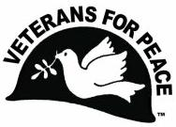
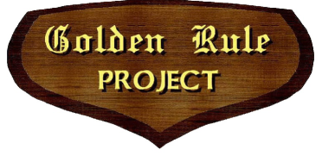
Dear <Organization>,
VFP Golden Rule Project
A National Project of Veterans For Peace
VFPGoldenRuleProject.org
Facebook.com/goldenrulepeaceboat
vfpgoldenruleproject@gmail.com
- 992-6364P. O. Box 87, Samoa, California 95564

The Golden Rule Peace Boat will be in <City> on approximately <Date> through <Date>.
Is the <Organization> interested in supporting the Golden Rule’s presentations in and the 2022 voyage around the “Great Loop”?
Background: In 1958 a crew of Quakers sailed the Golden Rule towards the Marshall Islands, intending to interfere with atmospheric nuclear weapons tests. As a result of this highly publicized mission and public outcry about the radiation blowing around the world, President Kennedy signed the Limited Nuclear Test Ban Treaty in 1963. The Golden Rule action inspired many peace makers and peace ships that followed, including Greenpeace.
Golden Rule was rescued from a watery grave in 2010 and restored to her former beauty by Veterans For Peace and others who support her new mission: to promote a nuclear free future, to educate about the dangers of radiation to humanity and the environment, and to support peaceful alternatives to war. We are advancing Veterans For Peace opposition to nuclear weapons, war and militarism in a dramatic fashion.
We support your mission! The Golden Rule Project supports the climate justice movement and conversion from fossil fuels and nuclear power to renewable energy. We also educate the public about wars fought for oil and how the U.S. military is the biggest single consumer of fossil fuels.
The Golden Rule is a “Weapon of Mass Education”. Her bright red sails with a giant peace symbol and Veterans For Peace logo attract a diverse audience, allowing us to “Preach Beyond the Choir”.
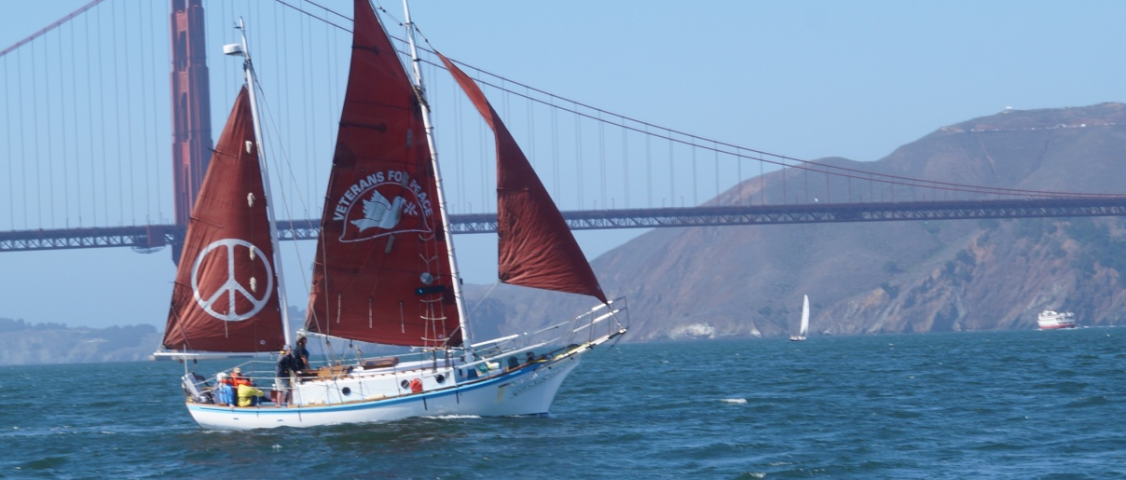

Our organizational sponsors benefit greatly from collaboration with the VFP Golden Rule Project. We can offer, depending on mutual interest and benefit, some or all of these options:
- A speaker from your organization is invited to speak at Golden Rule press conferences and educational events that you sponsor and will be invited to participate in interviews with the press.
- Your organization is featured on our press releases, flyers, Facebook page, web site and PowerPoint presentations as an event sponsor.
- Literature about your organization and issues will be distributed at events as a way to give the public a way to take action and be engaged.
- Contact information of attendees from events that you sponsor will be shared with your organization, and attendees will be encouraged to contact you.
What the VFP Golden Rule Project would like from our sponsors:
- Help us raise funds for the Golden Rule voyage – our goal is to raise $1000 average per stop. The money doesn’t all have to come directly from your organization and we can help with fundraising. Some of the funds will be donated at the events themselves by attendees.
- Promote the Golden Rule, events and the voyage to your members through your newsletters, social media, web site and email notifications.
- Assist in media outreach for the events and the voyage
Please consider this offer and contact me regarding your organization’s interest in sponsorship.
Sincerely,
Helen Jaccard
Veterans For Peace
Golden Rule Project Manager
(206) 992-6364
VFP Golden Rule Project
P. O. Box 87
Samoa, CA 95564
web: www.vfpgoldenruleproject.org
email: mailto:vfpgoldenruleproject@gmail.com
Phone: 415-794-5235

