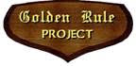
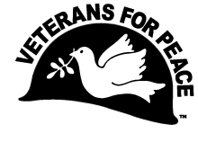
Celebrate First Anniversary of the Nuclear Ban Treaty!
Golden Rule Peace Boat Sails to San Diego County
Saturday, January 22 from 6:30 to 8:30 pm
Church of the Brethren 3850 Westgate Pl, San Diego, CA 92105
The world-renowned Golden Rule anti-nuclear sailboat is visiting San Diego County with an urgent call to eliminate nuclear weapons and prevent nuclear war. The historic 34-foot wooden ketch, a project of Veterans For Peace, will anchor celebrations of the first anniversary of the UN Treaty on the Prohibition of Nuclear Weapons, which went into effect on January 22, 2021. The Treaty bans developing, testing, deploying, using or threatening to use nuclear weapons.
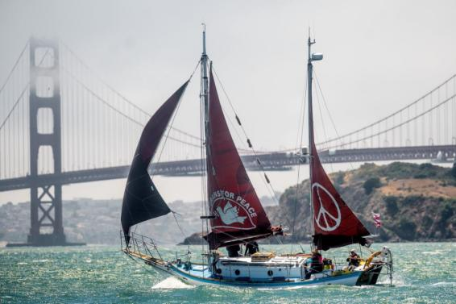
(c) Noah Berger, San Francisco Chronicle

- A Saturday evening event at Church of the Brethren will feature
- -- David Valladolid of Parent Institute for Quality Education
- -- Estela de los Rios, Executive Director of Center for Social Advocacy
- -- Gerry Condon, Veterans For Peace Nuclear Abolition Working Group
This is also an opportunity for the friends and family of Wil Van Natta to remember and honor his life of service.
“We are sailing for a nuclear-free world and a peaceful, sustainable future,” says Helen Jaccard, Golden Rule Project Manager. “The billions of dollars that are being wasted on nuclear weapons and war could be used to address poverty, the pandemic and climate change, while providing quality education and healthcare for all.”
In 1958 four Quaker peace activists sailed the Golden Rule from Los Angeles toward the Marshall Islands in an attempt to halt U.S. nuclear bomb testing. The U.S. Coast Guard seized the boat in Honolulu and threw the crew in jail. The international outcry that followed built support for the Partial Nuclear Test Ban Treaty that was signed in August 1963 by President John F. Kennedy and the leaders of the UK and the USSR.
The Golden Rule is currently on a mission to sail all throughout the United States with her message of peace, disarmament and sustainability. For more information, see www.vfpgoldenrule.org or call 206-992-6364.

Celebrate First Anniversary of the Nuclear Ban Treaty!
Golden Rule Peace Boat Sails to San Diego County

Saturday, January 22 from 6:30 to 8:30 pm
Church of the Brethren 3850 Westgate Place, San Diego, CA 92105
Covid protocols of the State, County, and Church will be followed.
Please bring a mask and respect social distancing guidelines. Please sit next to people you are normally exposed to.
Capacity is limited, so RSVP, if possible, to vfpgoldenruleproject@gmail.com
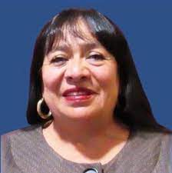
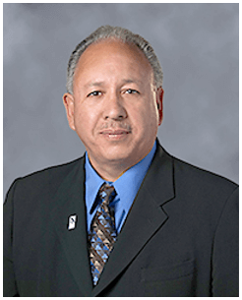
Featured speakers:

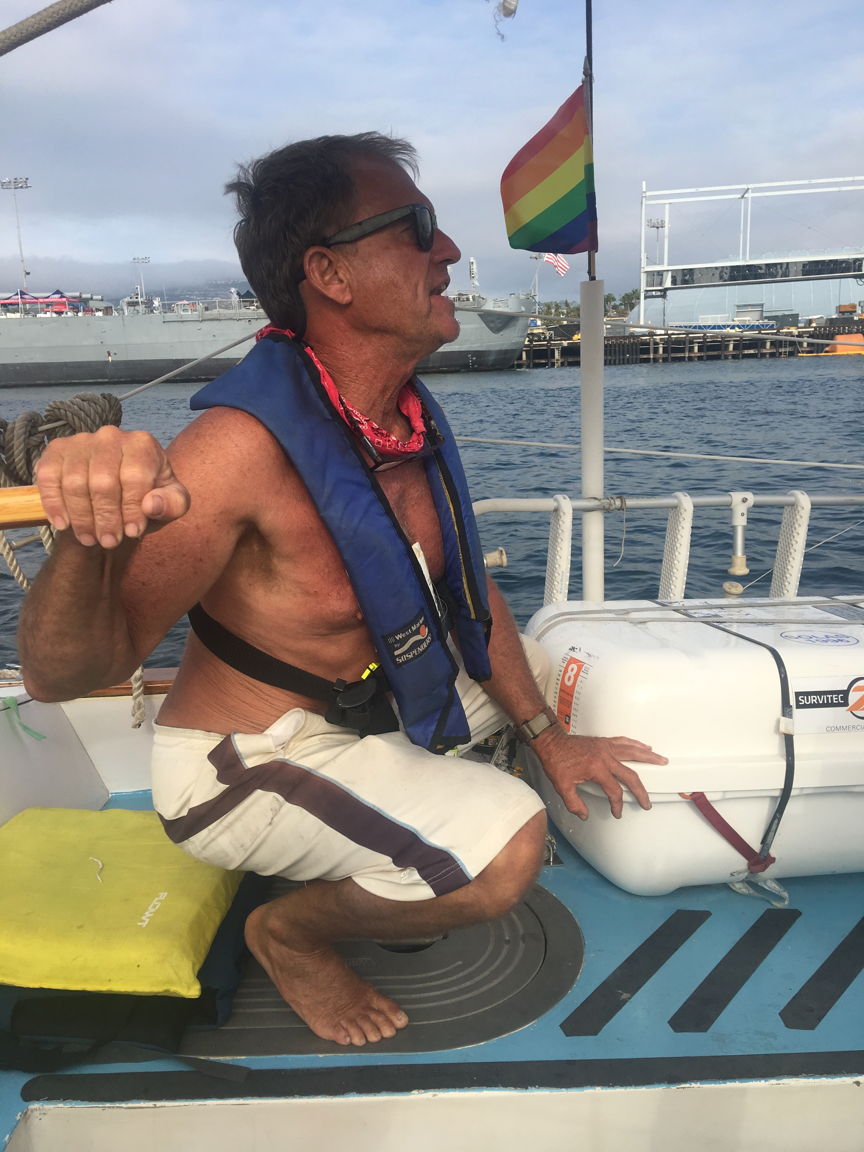
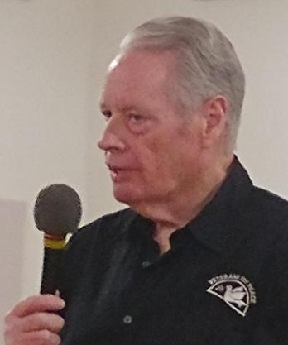
Veterans For Peace, Golden Rule Peace Boat
Would you like an educational presentation at your church / club / school? Would you like to sail or have a tour of the Golden Rule? Contact Helen Jaccard at vfpgoldenruleproject@gmail.com or 206-992-6364.
Organizational sponsorships, tabling opportunities are available!

Wil Van Natta, ¡Presente!
Long-time skipper of the Golden Rule,
Wil Van Natta, was killed in a tragic accident on December 10.
Wil’s sister Carol and other family will join us in remembering Wil this evening.
His ashes will be scattered from
Golden Rule, likely the morning of January 26. You are welcome to gather ashore while Wil’s ashes are scattered. Please coordinate with Helen Jaccard.
Gerry Condon
President of the Golden Rule Steering Committee.
Estela de los Rios
Executive Director of
Center for Social Advocacy
David Valladolid
President of Parent Institute for Quality Education

Golden Rule arrived from Hawai'i
into San Francisco Bay on June 1, 2021
Sailing for a Nuclear-Free World
and a Peaceful, Sustainable Future!
In 1958 peace activists sailed Golden Rule toward the Marshall Islands in an attempt to halt nuclear weapons testing. When the crew attempted to leave Honolulu, the US Coast Guard arrested her crew, causing an international outcry.
Rising public awareness of the dangers of radiation led to worldwide demands to stop nuclear testing. In 1963 President Kennedy, the U.S.S.R. and the U.K. signed the Limited Nuclear Test Ban Treaty
In 2010 the Golden Rule sank in a gale in Humboldt Bay in Northern California. Veterans For Peace (VFP) restored the boat and her original anti-nuclear mission. They’ve been sailing her on the West Coast and to Hawai’i and back.
VFP, a group of military veterans and their supporters, has 3000 members in 100 chapters. The Golden Rule Project aims to advance Veterans For Peace opposition to nuclear weapons and war, and to do so in a dramatic fashion.
After giving over 300 educational presentations and media coverage reaching hundreds of thousands of people, the Golden Rule Project is well known and loved!

The Golden Rule will be in San Diego County January 25 - February 20.
Follow the Golden Rule's progress along the California Coast Jan 16 - 25: share.garmin.com/goldenrule

Full Event Schedule:
Jan 16 - Jan 25: Golden Rule en Route to San Diego - follow at share.garmin.com/goldenrule
- Sat Jan 15, 1 pm to 3 pm: Educational Presentation, BY ZOOM (Link to recording is coming soon).
- -- Reverend Dr Beth Johnson, Co-Chair of California Poor People’s Campaign
- -- Yusef Miller, Racial Justice Coalition of San Diego and organizer for religious and racial equality
- -- Helen Jaccard, crew and Project Manager of the Golden Rule Peace Boat
- -- Gerry Condon, past President of Veterans For Peace, President of Golden Rule Steering Committee
Tue Jan 25 - Thur Jan 27: Shelter Island Harbor Police Dock, 1401 Shelter Island Dr, San Diego, CA 92106
- Sat Jan 22, 7 to 9 pm: Educational presentation
- Church of the Brethren, 3850 Westgate Pl, San Diego, CA 92105
- First Anniversary of the UN Treaty on the Prohibition of Nuclear Weapons
- Featuring:
- -- David Valladolid of Parent Institute for Quality Education
- -- Estela de los Rios, Executive Director of Center for Social Advocacy
- -- Gerry Condon, Veterans For Peace Nuclear Abolition Working Group
- Wed Jan 26, 8 am to noon: Scatter ashes of Wil Van Natta
- Wed Jan 26, 1 pm to 3 pm: Press Conference
- Yokohama Friendship Bell, 1500 Shelter Island Dr, San Diego, CA 92106
Sat Jan 29 - Sun Jan 30: Ensenada, Mexico
Tues Feb 1 - Fri Feb 11: Shelter Island Harbor Police Dock, 1401 Shelter Island Dr, San Diego, 92106
- Fri Feb 4, 7 to 9 pm: Educational Presentation and Music
- World Beat Center, 2100 Park Blvd, San Diego, CA 92101
- Featuring
- -- Frances Yasmeen Motiwalla, Activist San Diego
- -- Clovis Honore, San Diego NAACP
- Sat Feb 5, 1 to 3 pm: Educational presentation (by Zoom)
- Sponsored by: First UU Church of San Diego
- Featuring
- -- Barry Ladendorf, Past National President of Veterans For Peace
- -- Gary Butterfield, Veterans For Peace, Climate Crisis and Militarism Project
- -- Marjorie Cohn, National Lawyers Guild﻿
- Zoom link

