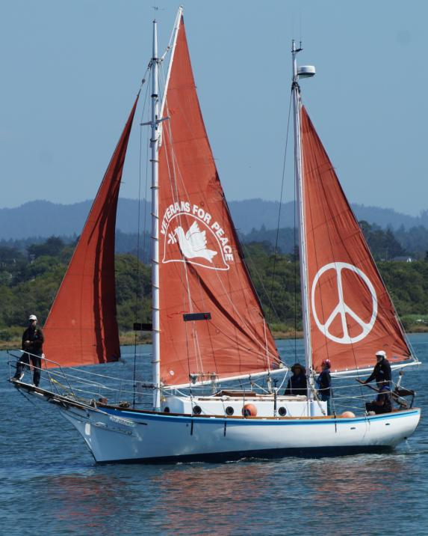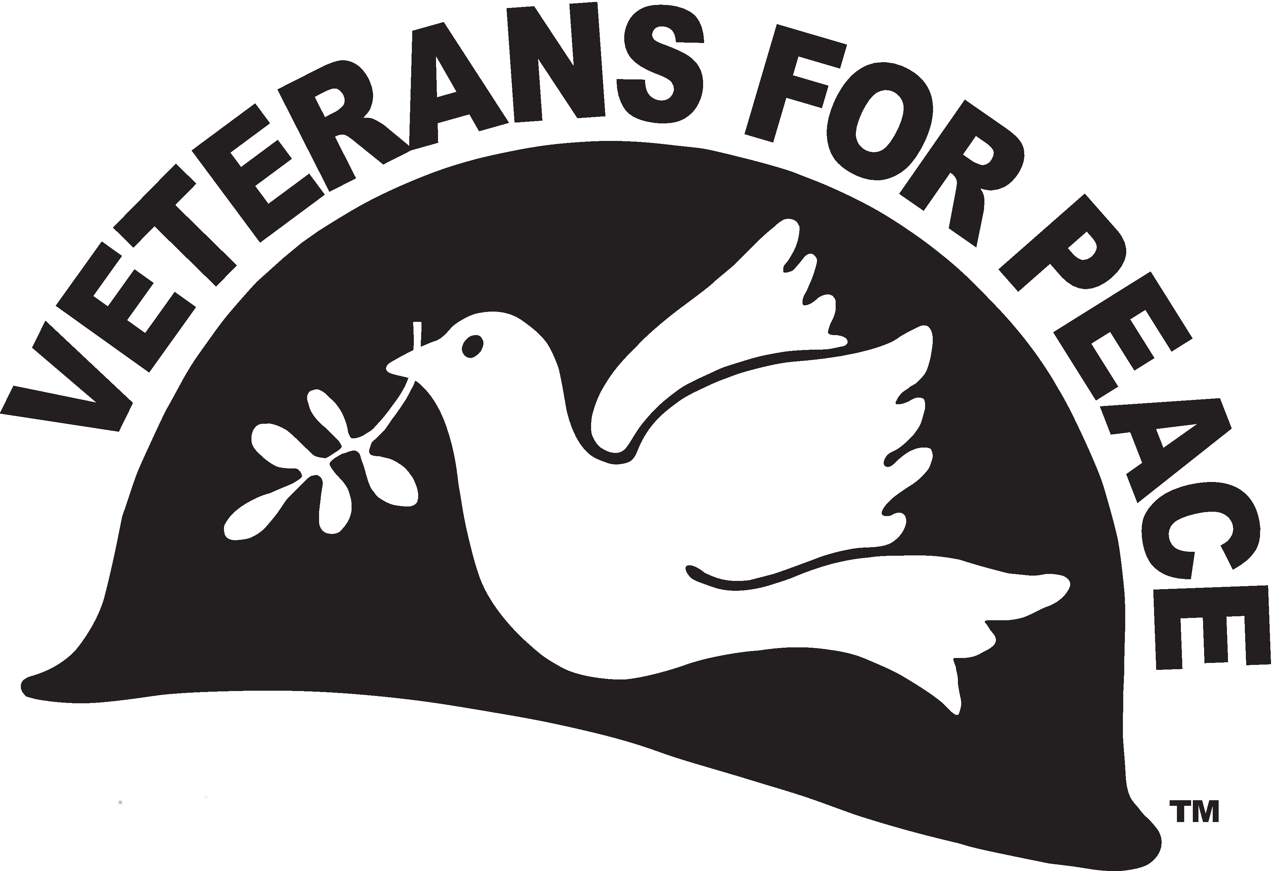

Commemorating the 75th anniversary of the   
US nuclear bombing of the civilian populations of   
Hiroshima and Nagasaki

4:00 to 4:30 pm

Meet under Banyon tree at the tip of Magic Island on the West (Ewa) side

Meaningful words, moment of silence,

Group photo

2 pm: Golden Rule Leaves Waikiki Yacht Club

Shore people “see us off” from Magic Island along the channel

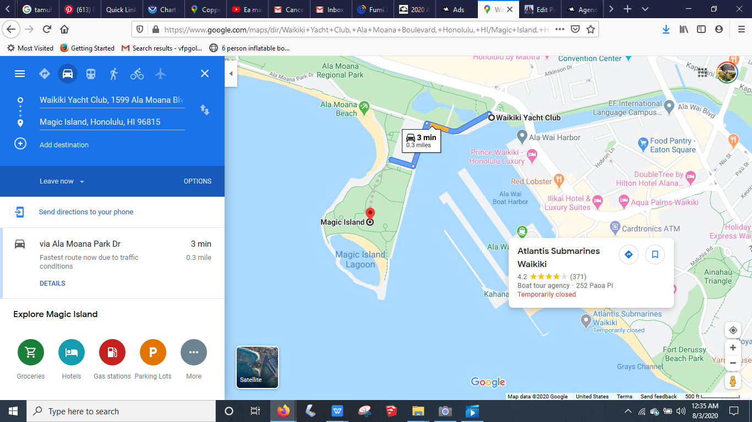

**Ban Nuclear Weapons! De-Militarize the Pacific!**

**August 6 and 9, 2020**

Everyone - shore people, crew, and guests on the Golden Rule will wear masks and social distance

2:00 pm: Golden Rule leaves Waikiki Yacht Club

Shore people are on Magic Island on the channel with signs, banners to “see us off”

2 - 3:30 pm: Golden Rule sails towards Diamond Head and back, with banners saying, “Ban Nuclear Weapons” and  
 “De-Militarize the Pacific”

Shore people pass out leaflets about the bombing and truth about the end of World War II

3:30 - 4:30 pm: Golden Rule sails back and forth, as close to Magic Island as possible

Shore people gather and have a short program starting at 4:00 pm

4:30 - 5:00 pm: Golden Rule sails through the channel back to Waikiki Yacht Club

Shore people welcome Golden Rule back into the harbor

Unfortunately, the parking lot of Magic Island is closed due to construction - there is street parking only - hopefully this won’t pose too much of a problem!

For more information, contact:

Helen Jaccard

206-992-6364

vfpgoldenruleproject@gmail.com

3:30 to 4:30 pm: Golden Rule sails back & forth as close to Magic Island as possible

2 pm to 3:30 pm: Golden Rule sails towards Diamond Head and back