Against the Wind Festival

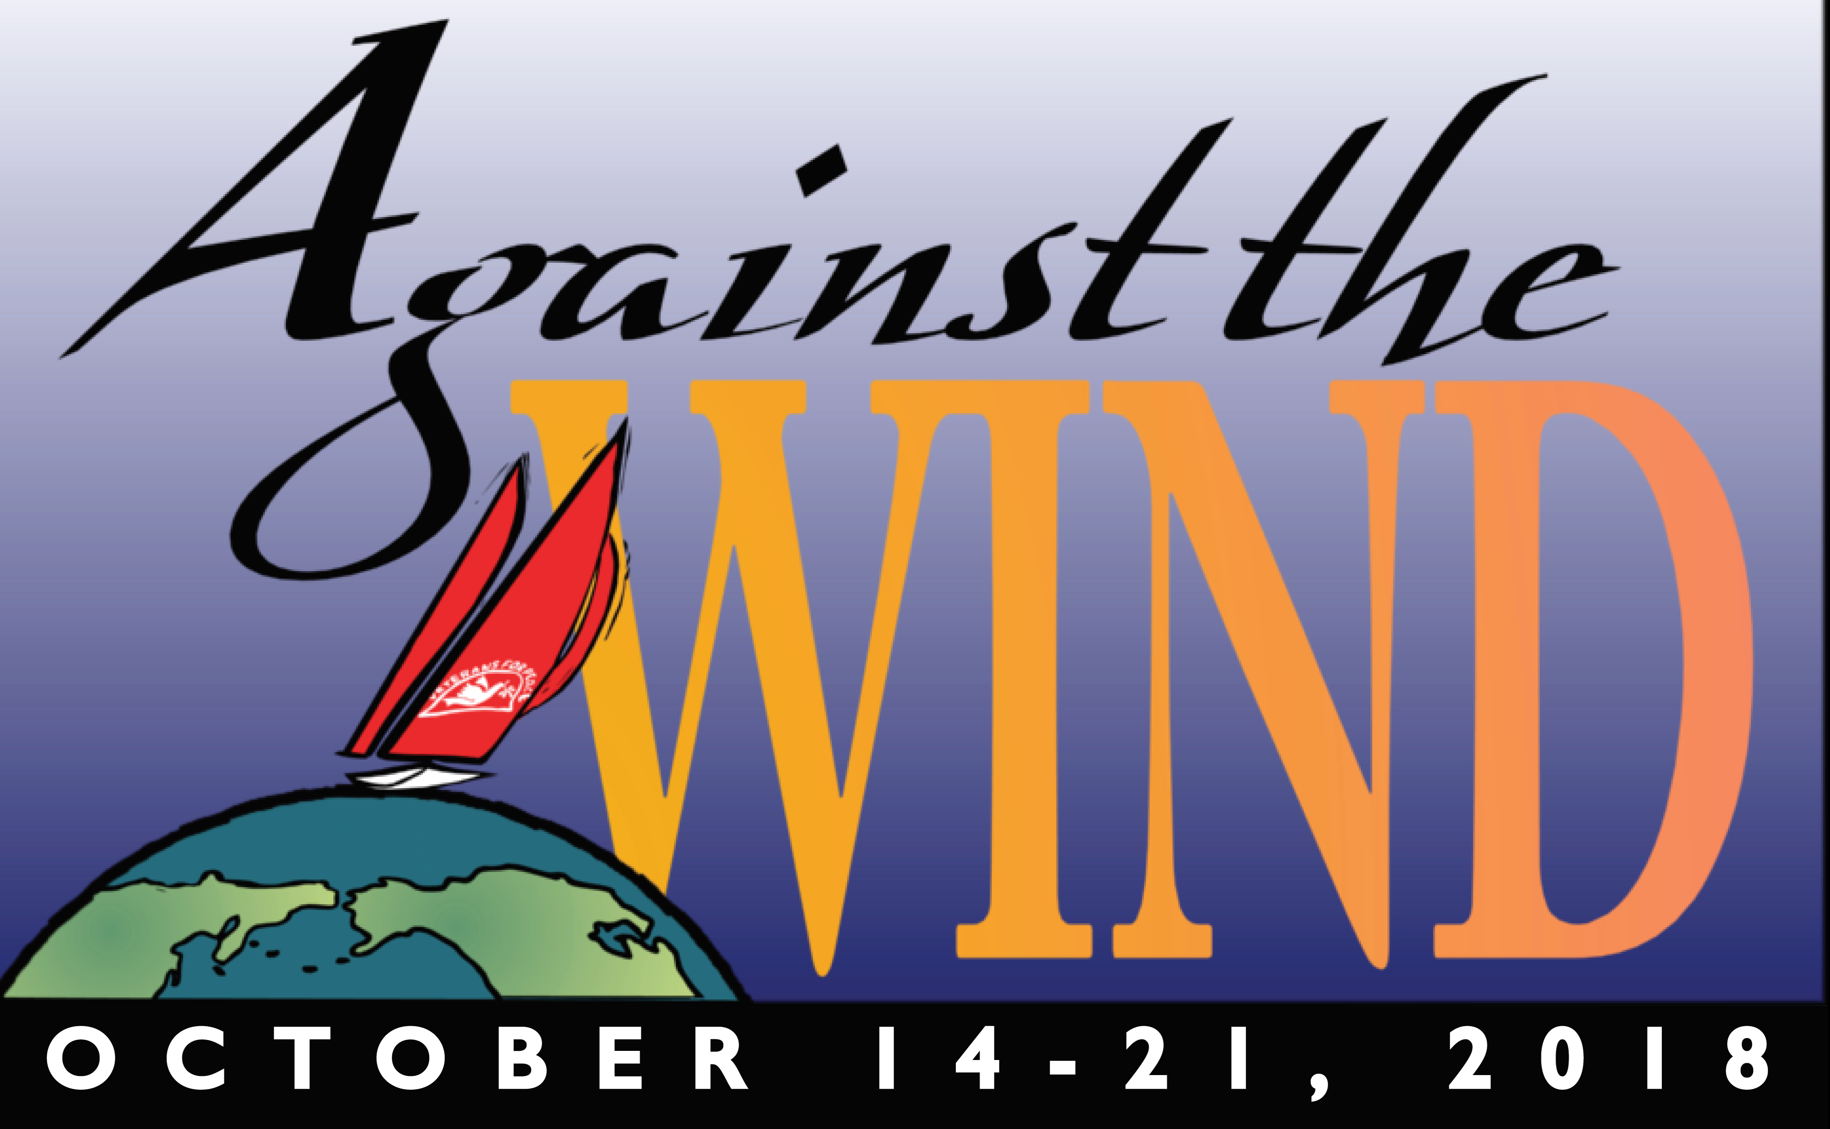By all measure, the Against The Wind Festival was a huge success !

Festival organizers accomplished their initial goal of raising money for the Golden Rule (nearly $15,000!) and her mission, and moved toward our other goals of providing information and inspiration to Humboldt Bay communities on important issues of nuclear threats to all living things.

The Steering Committee, led by Jack Irvine, included John Heckel, director of Which Way the Wind; Jane Hill, Promotion Director; Amy Uyeki, Art Director; Peter Pennekamp, facilitator and Peter Aronson, Liaison between Against the Wind Festival and the Golden Rule Project.

We are very grateful to the many commercial and public supporters and especially to the
invited guest speakers, experts in their respective fields.

The Festival began on a Sunday night, a risk that paid off , as more seats than set were required to accommodate attendance at POWER OF PROTEST - Songs of Resistance.

The next event, a forum discussion called MORTALITY, MORALITY & THE ATOM BOMB, was moderated by a popular Arcata ex-mayor and included a panel of experts we were very fortunate to assemble. That panel included the following.

Robert Gould, MD, President of SF Bay Area Physicians for Social Responsibility was one of four panelist for MORTALITY, MORALITY & THE ATOM BOMB. He also led a post-film discussion after the following films: 24 Hours After Hiroshima; Anointed; Making Waves: The Rebirth of the Golden Rule; and Dr. Strangelove comprised a film night called REELING IN THE BOMB.

Dale Preston, PhD, a biostatistician with 40 years experience describing and quantifying health effects of radiation in humans, played a central role in developing modern methods and tools used to characterize radiation effects.

Reweti Wiki, an indigenous New Zealander, held various roles working with and for tribal governments focused on improving social and economic outcomes for indigenous people, including nuclear use and testing.

Lawrence Wittner, PhD, emeritus professor of history at SUNY/Albany has written
extensively on peace movements, foreign policy, and economic inequality. Author of nine books and 400 articles, his latest Confronting the Bomb is a short history of the
world Nuclear disarmament Movement. Wittner spoke at two university classes and was keynote presenter of an evening lecture THE GOLDEN RULE & THE CAMPAIGN FOR A NUCLEAR FREE WORLD.

Another Festival success included a wonderful response to local art teachers to invite student artists to reply to “What would the world look like after war or peace?”, from which a 64 page color booklet was published called FRESH PERSPECTIVES ON WAR AND PEACE. A slide show of this amazing art was put to music and will become part of the Against the Wind website, https://againstthewindfestival.org.

The centerpiece and inspiration of our Festival, restating of the play Which Way the Wind was a hit each of the three performances. Director Heckel led a “talk back” at the end of each performance that provoked a wide range of issues and emotions.

We videotaped the panel discussion, the Power of Protest, and Wittner’s Humboldt State
University lecture. These documents will also be added to our website after editing.

A huge thanks to the commercial sponsors: Humboldt Access Project, Jewell Distillery, Los Bagels, Mad River Brewery, Kokatat, Minor Theater, Morse Media, Pierson’s Building, Ramones Bakery, and College of Arts, Humanities and Social Sciences, HSU.

And thank you to the generous Humboldt Bay community for their support in donations, attendance, and activism. Their participation and comments - “very worthwhile”, “important”, “inspiring” - reinforces our intended objectives to educate & inspire, and provide ongoing wind in Golden Rule’s mission.

