Three sisters - Golden Rule, Phoenix of Hiroshima, and the Lucky Dragon 5
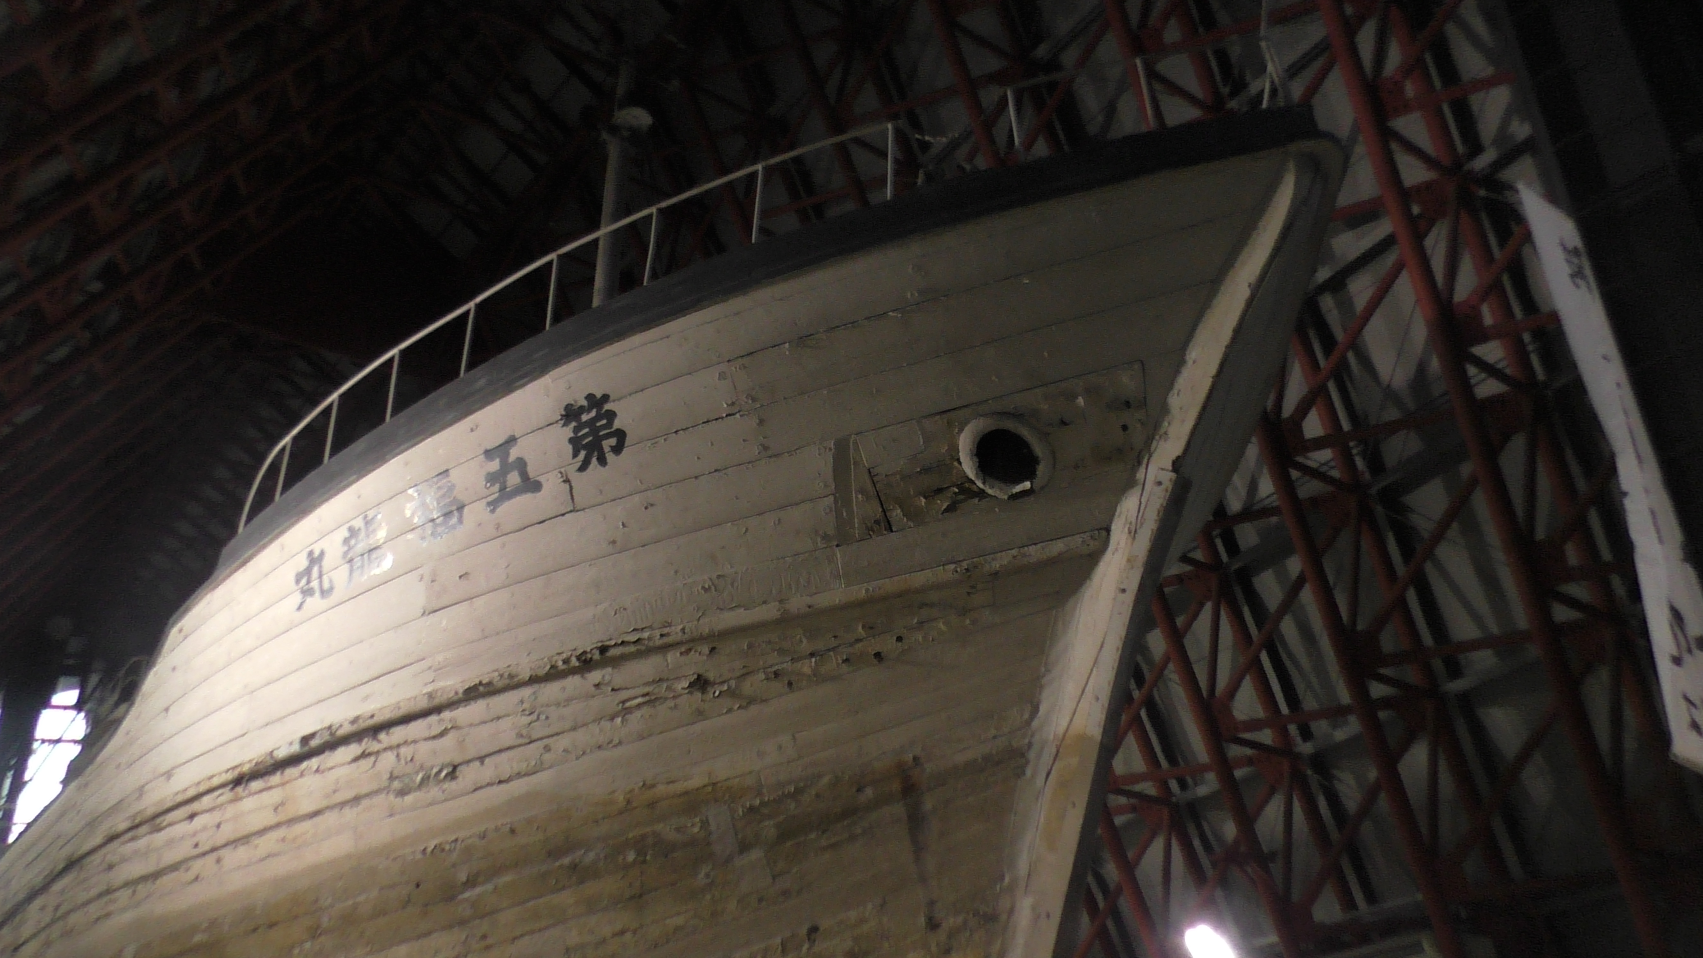
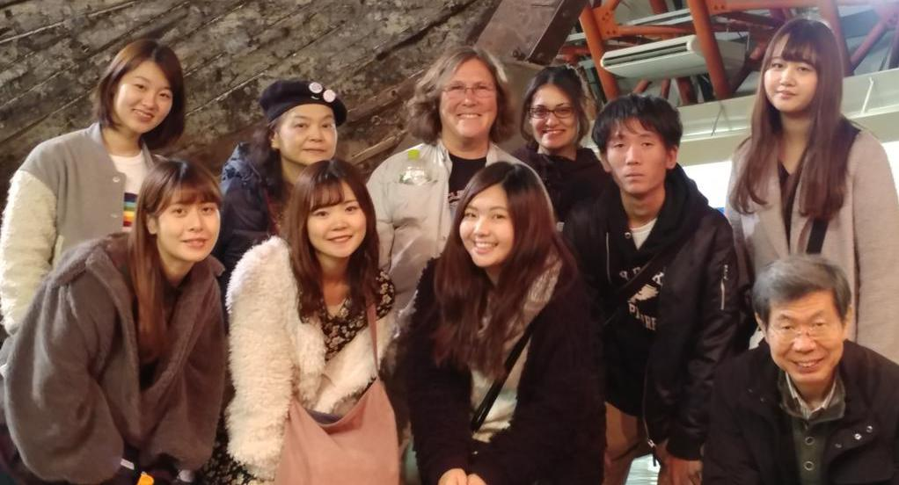
There are really 3 sister ships in the 1958 story - the third being Daigo Fukuryū Maru, the Lucky Dragon 5, a tuna fishing boat which was exposed to the Castle Bravo nuclear bomb fallout on March 1, 1954. Twenty three of its crew became severely ill with radiation sickness and one died within a month. It s a sister ship because the crew are also considered “Hibakusha” (radiation survivors) and because the focus of the museum in Tokyo is about much more than the Lucky Dragon 5 - it is about all of the nuclear bomb tests and their effects on the people. It is also about nuclear bombs in general, so it tells the story of the nuclear era quite well.
This museum, which houses the Lucky Dragon 5 tuna fishing boat, tells the story of how this boat had its nets in the water before the dawn of March 1, 1954. The sun rose too bright as the Castle Bravo atomic test exploded over the Marshall Islands. The fishers didn’t know what it was, but soon the sound wave hit them and then the ash started falling on their skin and burning them. 23 people were very sick from radiation poisoning. One died within a month, another within 2 months. There is a chart explaining who the fishers were and their date of death. Five are still living, but all are very ill.
Before they left the area of the Marshall Islands, it took them 4 hours to pull in their tuna catch - all the while being exposed to more fall-out which they didn’t know what it was. But soon 23 of them started vomiting blood and had other severe symptoms and the boat headed back toward Japan. It took 2 weeks to make the voyage. The sick were put in one hospital but had to transfer to another to get proper care.
Their catch of tuna was put for sale at the local market. Before long, people found out that the fish were radioactive. Some had already been sold and eaten. The rest, 800 big tuna, were buried.
The Lucky Dragon 5’s catch was not the only contaminated tuna. Many other fishers had been in the Marshall Islands and French Polynesia over years that the nuclear bombs were dropped there, and many other fish were contaminated. Rain brought even more contamination to Japan and the crops were also contaminated. This caused massive economic hardship because the fishers and farmers couldn’t sell the food!
The museum has good charts of all of the atomic bomb tests, anti-nuclear art work, books, and other materials.
Lucky Dragon 5 is really large compared with the Golden Rule. About 3 times as long, twice as wide and very tall and deep. It’s pretty impressive to walk around her.
We were joined by Mera Seijiro, Bureau Chief of Article 9 Society for a Global Peace Charter and VFP Japan member.
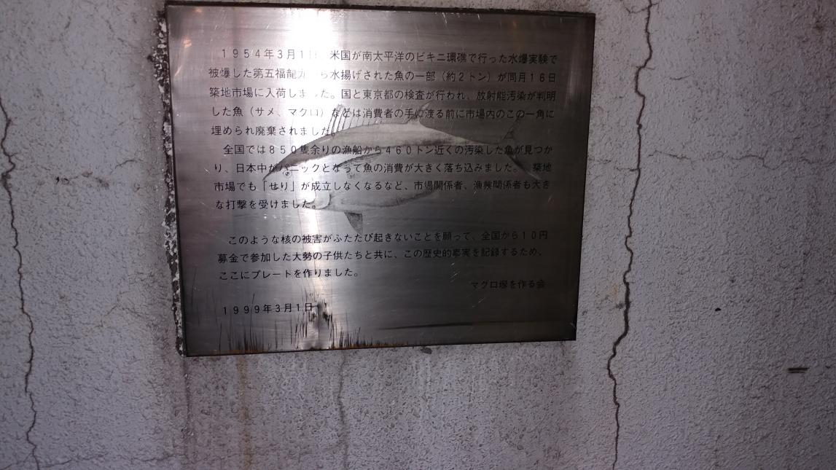
We walked to a local market and saw where the fish from the Lucky Dragon 5 were buried. This is a plaque to let the public know about these contaminated fish.

