Japan Report Back - Lessons from Fukushima
On Dec 5 and 6 Ms. Naoko Suzuki, Ms. Yuri Kadoya-Ogata, Ms. Hanoya Oyo, Mr. Mera Seijiro, Masato Nakamura and I went on a bullitt train, my first, to Fukushima train station in Fukushima City.
Ghost towns, abandoned homes and farms, roadblocks and closed gates, workers with masks
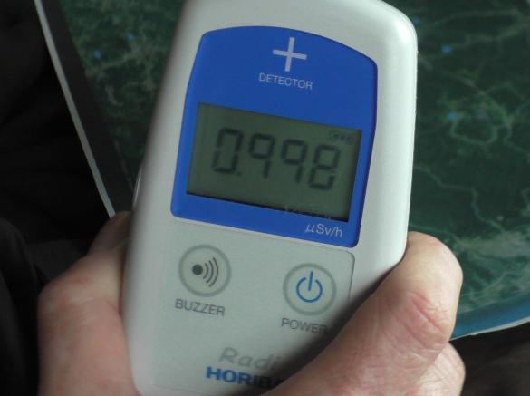
We drove over the mountains to within 6 miles of the Fukushima Daiichi nuclear power plant. On the way, we passed dozens of abandoned villages, blocked off by gates and guarded by men with dust masks. We saw many, many abandoned homes and farms. Many of the farms obviously were undergoing decontamination - the fields were scraped off and nothing grew there.
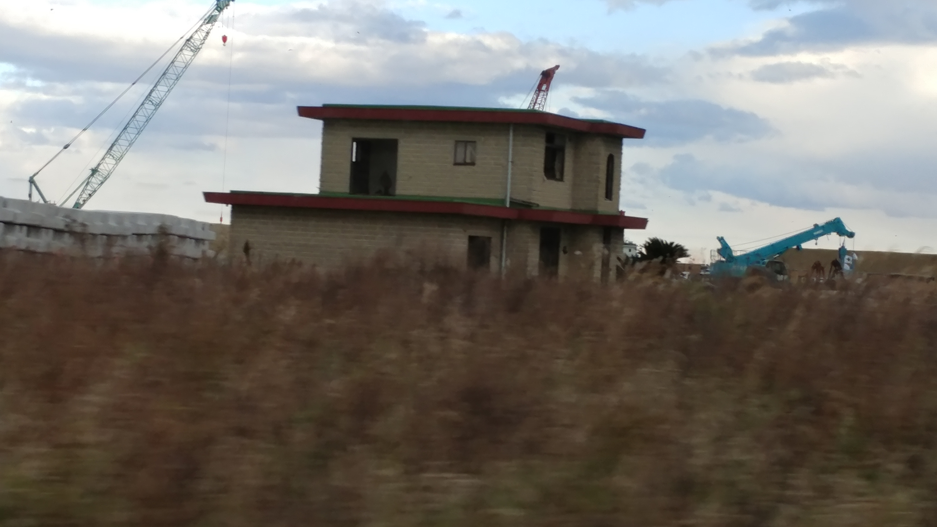
We monitored the radiation level as we went. The maximum we measured was 2.5 microsieverts per hour.
Resistance and Protest: Our first stop was to visit Masami Yoshizawa, a Japanese “cowboy” who told us that the government ordered all of the irradiated cattle to be killed.

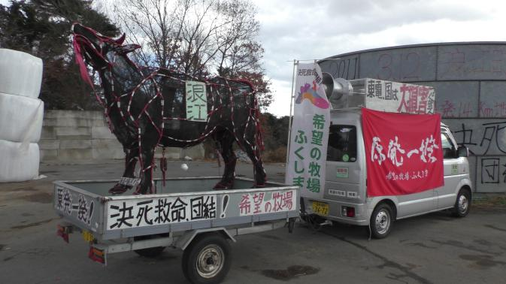
Some ranchers did, but some abandoned their cows to die of starvation. In this picture, the cows were left in their feeding stations, trapped while they died from lack of food and water. But the cowboy we visited, decided to stay and care for his cows until he and the cows all die from more natural causes! "I am a cowboy, and cowboys do not abandon their cows. I will stay with them until I die."He protests against the government’s orders to leave the evacuation zone and kill his cattle using his portable cow statue.
As we talked, he showed us a picture of one of several of his cows that has developed white spots as a result of the radiation. It reminded me of cows in Tennessee near the depleted uranium munitions factory (Jonesboro, TN) where they paint their cows so that nobody will find out about the contamination.
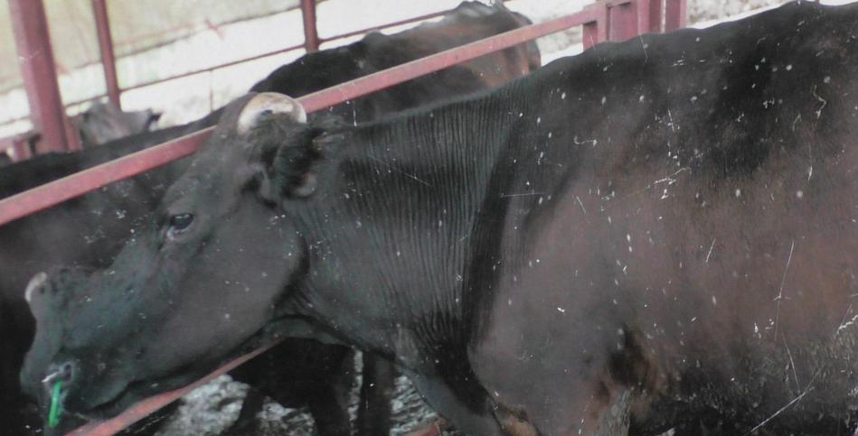
The six of us stayed in a cabin on a mountain in Fukushima Prefecture the night of Dec 5. We had a bath in the hot springs, Japanese style - a long shower followed by a soak in the hot tub from the hot springs. Nude, one gender per room. It snowed lightly that night so was incredibly beautiful!

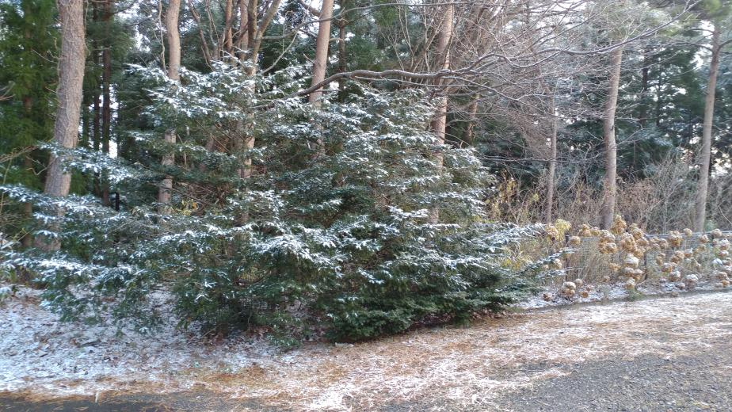

Miles of contaminated garbage

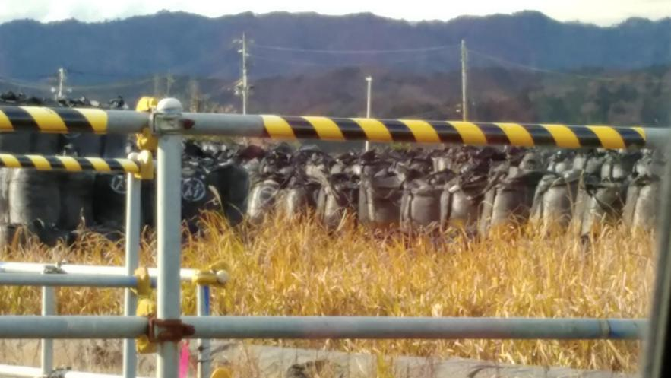
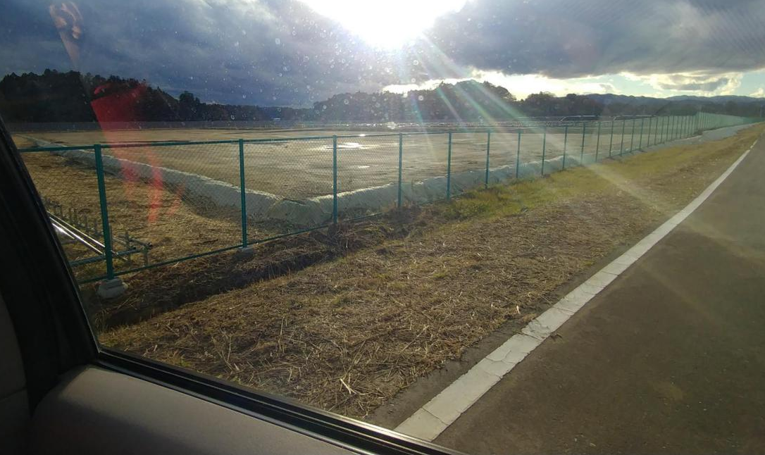
Men only doing decontamination work, housing areas and restaurants for the workers 6000 of them
Make-work projects - propaganda building, toxic sea wall - many of the same huge companies that built the NPP now profit from its demise.
Additional danger - if another earthquake, tsunami or typhoon hits the NPP it could be an even faster disaster
Abe government approving restarting NPPs and wants more NPPs
Sumio Konno story
Stories from other evacuees -
* moved multiple times,
* may have to return to contaminated homes
* changed acceptable standards
* divorces
* subsidies being removed

Ms. Ruiko Mutoh gave us a very informative presentation about the water contamination at the Fukushima Daiichi nuclear power plant. Even before the accident, ground and water was diverted away from the nuclear power plant, but this system was destroyed in the accident.
From the beginning, TEPCO and the Japanese government wanted to allow the contaminated water to go to the ocean but the fisher association and other Fukushima residents stopped them.
The vent towers over units 1 and 2 to release into the air, are corroded and broken, well documented in 2013. A Japanese newspaper covered this issue April 6, 2017. 10 - 20 sieverts per hour are measured near these towers. This only gives you 7 minutes of exposure before it is fatal. Another concern is that a tower could break further and crash into a cooling pond. In this case, she speculates that the radiation would reach Tokyo. Now that the fuel rods are being removed from Unit 3, it is possible that one of those cranes could cause an accident, too!

