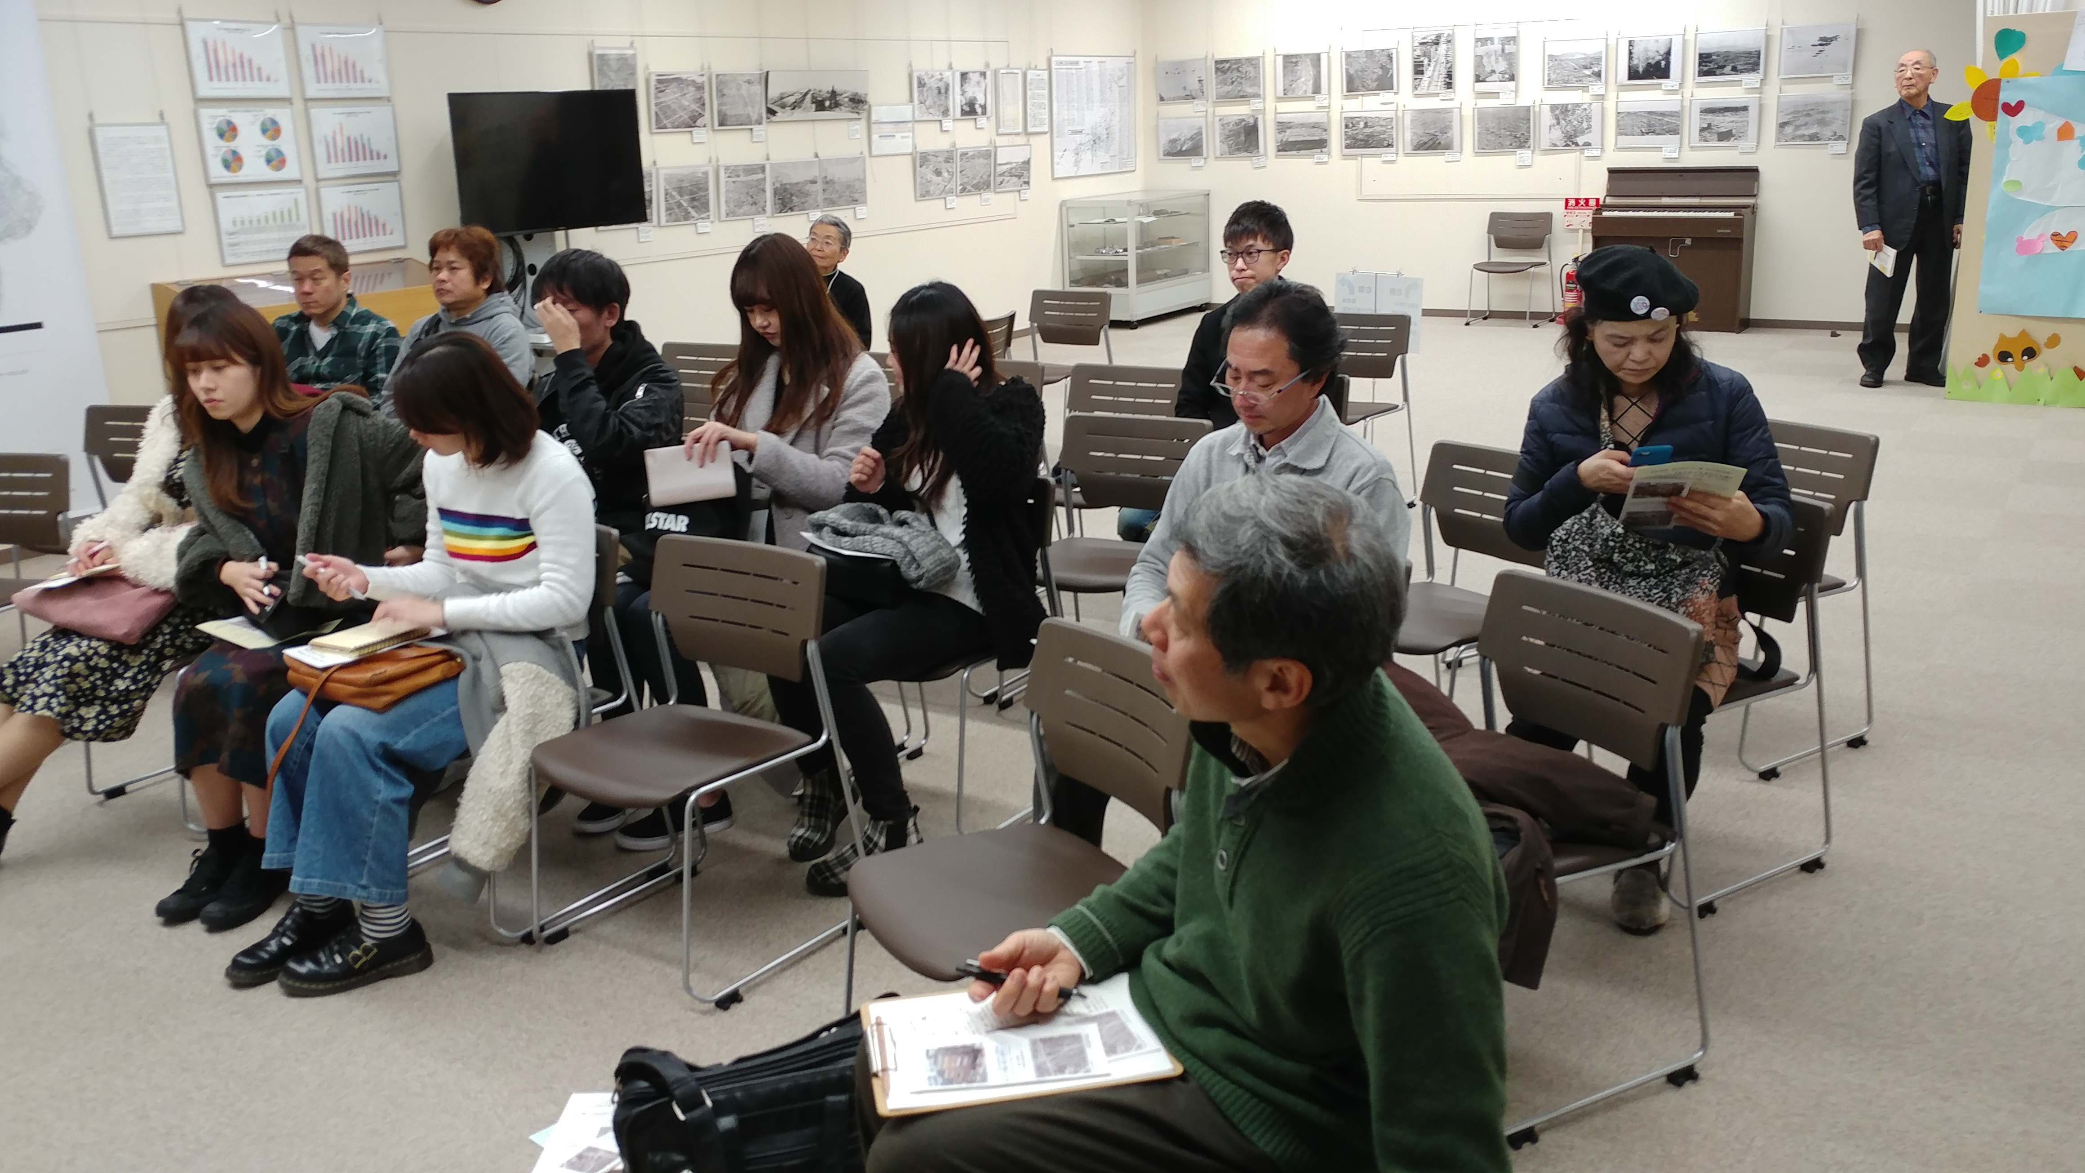
The Center of the Tokyo Raids and War Damage is about the bombing of Tokyo by the U.S. in March and May of 1945. Shiraishi Tetsuzo, who survived the bombs as did his family, came to tell us the story.
Of Japanese history, half is about war. We have decided to live in peace. I’m happy to live now, when Japan is not involved in war. War is usually between two countries and parliamentarians decide to go to war - not all of us are asked because there is not time to listen and decide.
Shiraishi Tetsuzo
Survivor of Tokyo napalm bomb raid
Prof. Takao Takahara, 6 of his students from the International and Peace Studies programs at Meiji Gakuin University, and Masato Nakamura and Yuri Kadoya-Ogata from Veterans For Peace Japan went with me to the Center of the Tokyo Raids and War Damage and the Lucky Dragon 5 museum.
I’m very happy about Article 9 of the Japanese constitution and feel very sad when I hear talk of that changing.
I was 7 years old during the bombing and am 80 years old now. When we survivors are gone, no one will really be able to understand what happened.
There were many failures, but the big one was not caring about the people - the mission was to kill as many people as possible and the U.S. exceeded well beyond their killing goals.
After 3 years 8 months into the Pacific war the Pacific was controlled by America and the U.K.
Japan’s empire had controlled many places - China, Manchuria, Mongolia - they spread everywhere in Asia. These were invasions for natural resources, mainly. They deprive people of their rights. Japan wanted a great economy, and that’s why they went to war. Economy and war are related, just as in North Korea now.
In 1940, the U.S. started to consider destroying Japan because of natural resources.
The army placed bombs everywhere in Japan to make it faster to bomb Tokyo. Japan was one of the largest U.S. properties in Asia.
The bombs were dropped from 10,000 meters.
My 5 brothers and sister and I (and parents or at least his father) all survived the bombs. I ran away from the center of Tokyo with my older sister. We were looking for a place that was dark and not on fire. Our family was separated and there were flames everywhere and buildings falling in place. We tried for two hours with many others to find shelter. We ended up underground.
The bombs and fires killed 10,000 people in my area. Many places just melted, especially metal.
Even though there was no radiation, it was even worse than a nuclear bomb - these were napalm bombs and if you get any on your skin it burns and burns. We were afraid of the US army and their strategy to kill so many people.
(We saw many horrible pictures and drawings on the projector screen!)
We used our gardens to bury the dead (showed a map with orange dots showing where the bodies were buried). After 3 years, we exhumed the bodies and burned them at Kokogikan in the Japanese traditional way, all together, because we didn’t know who they were - whole families died. We burned them on March 10.
Half of the residential area was bombed.
General Curtis LeMay talked in the film about cloud cover being a problem with the B-29 bombers. We were supposed to be running at high altitude, but he all on his own ordered the bombs to fly at low altitude and to drop napalm bombs. That order was on 7 March, 1945.
They took out the bridges over the rivers, cutting out avenues of escape.
Wind fanned the flames.
The Japanese military needed to protect the Emperor, so hid him underground.
In some districts, 2/3 of the people were killed. In all, over 100,000 people died.
In the film a bombadier who now lives in Newport Beach showed off all of his metals. He shows no remorse.
Nineteen years after the attack, pictures and art documents were finally released.
Question - was water a safe refuge? Not really - it was a really cold winter. The water was 3 degrees celcius and the wind was very strong. And the ashes fall on your head and burn you.
The flames consumed the oxygen, so there wasn’t enough to breath.
Mr. Tetsuzo went back to elementary school after a year, but it was being used as a shelter, so they couldn’t really study. He went to a different school after that, where his grandchildren are going now. That year only four cherry trees bloomed.
Question: did you hate the U.S. soldiers that lived in Tokyo? No, I had no particular feelings about them. We didn’t talk to each other. We just learned and felt that we couldn’t beat them in the war. But it wasn’t just about war, it changed the fate of the countries. I didn’t experience hatred. I think about peace, but also war and what I’ve been through. This bombing was not really perceived as war but as a disaster and we concentrated on survival. Everyone was going through he same thing together. It affected our lives in all ways, including financially.
After the war, people worked to build a peaceful Japan. They formed the constitution modeled after the one of American democracy.
We looked around the Center for awhile, viewing pictures of bodies, displays of melted metal, drawings of the city in flames.
For me, this represents a common war crime - the murder of tens or hundreds of thousands of innocent civilians for the purpose of bringing down a government and making change. I felt like apologizing on behalf of my country. Regardless of what Japan was doing to its neighbors, it was wrong for the US to drop napalm on all of those cities - around 100 cities were fire bombed before the final evil acts, the atomic bombing of Hiroshima and Nagasaki.

