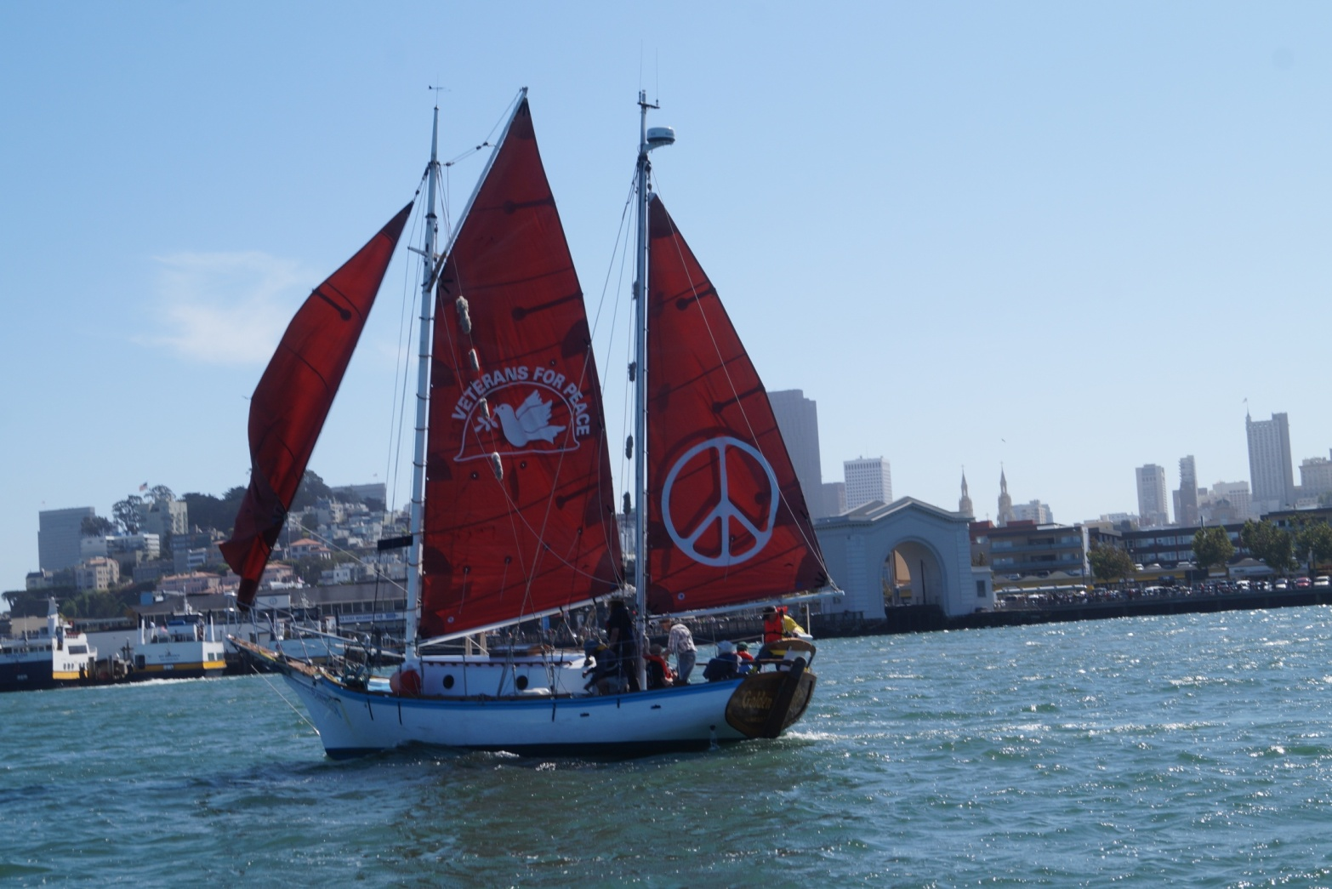

**Welcome the *Golden Rule* to Hood River!**

**Wednesday June 15, 2016**

In 1958 a crew of Quaker peace activists attempted to sail the *Golden Rule* to the Marshall Islands to interfere with US nuclear bomb testing. This bold nonviolent direct action inspired a worldwide movement leading to the Partial Nuclear Test Ban Treaty of 1963.

After five years of restoration by Veterans For Peace and many friends, the *Golden Rule* is once again sailing for a nuclear-free world and a peaceful, sustainable future!

**During the day**: The *Golden Rule* peace boat will be available to tour and take people sailing at the Port Marina Park dock.

**5:00 pm**: Indigenous Water Blessing and Potluck Picnic at the Port Marina Park – bring some food and drink and enjoy chatting with the crew.

**7:00 to 9:00 pm**: Riverside Community Church Sanctuary, 317 State St:

**HELEN JACCARD, VFP Golden Rule Project Manager**

**LLOYD MARBET, Oregon Conservancy Foundation**

**CHUCK JOHNSON, Physicians for Social Responsibility**

**LAUREN GOLDBERG, Staff Attorney, Columbia RiverKeeper**

**MR. LOYD HENION, Living Islands Advisory Ambassador**

***Music by* SCOTT BERGERON AND REBECCA STONE STREET**

**Event sponsored by:**

**Veterans For Peace**

For more information, call 971-282-9986 or 206-992-6364