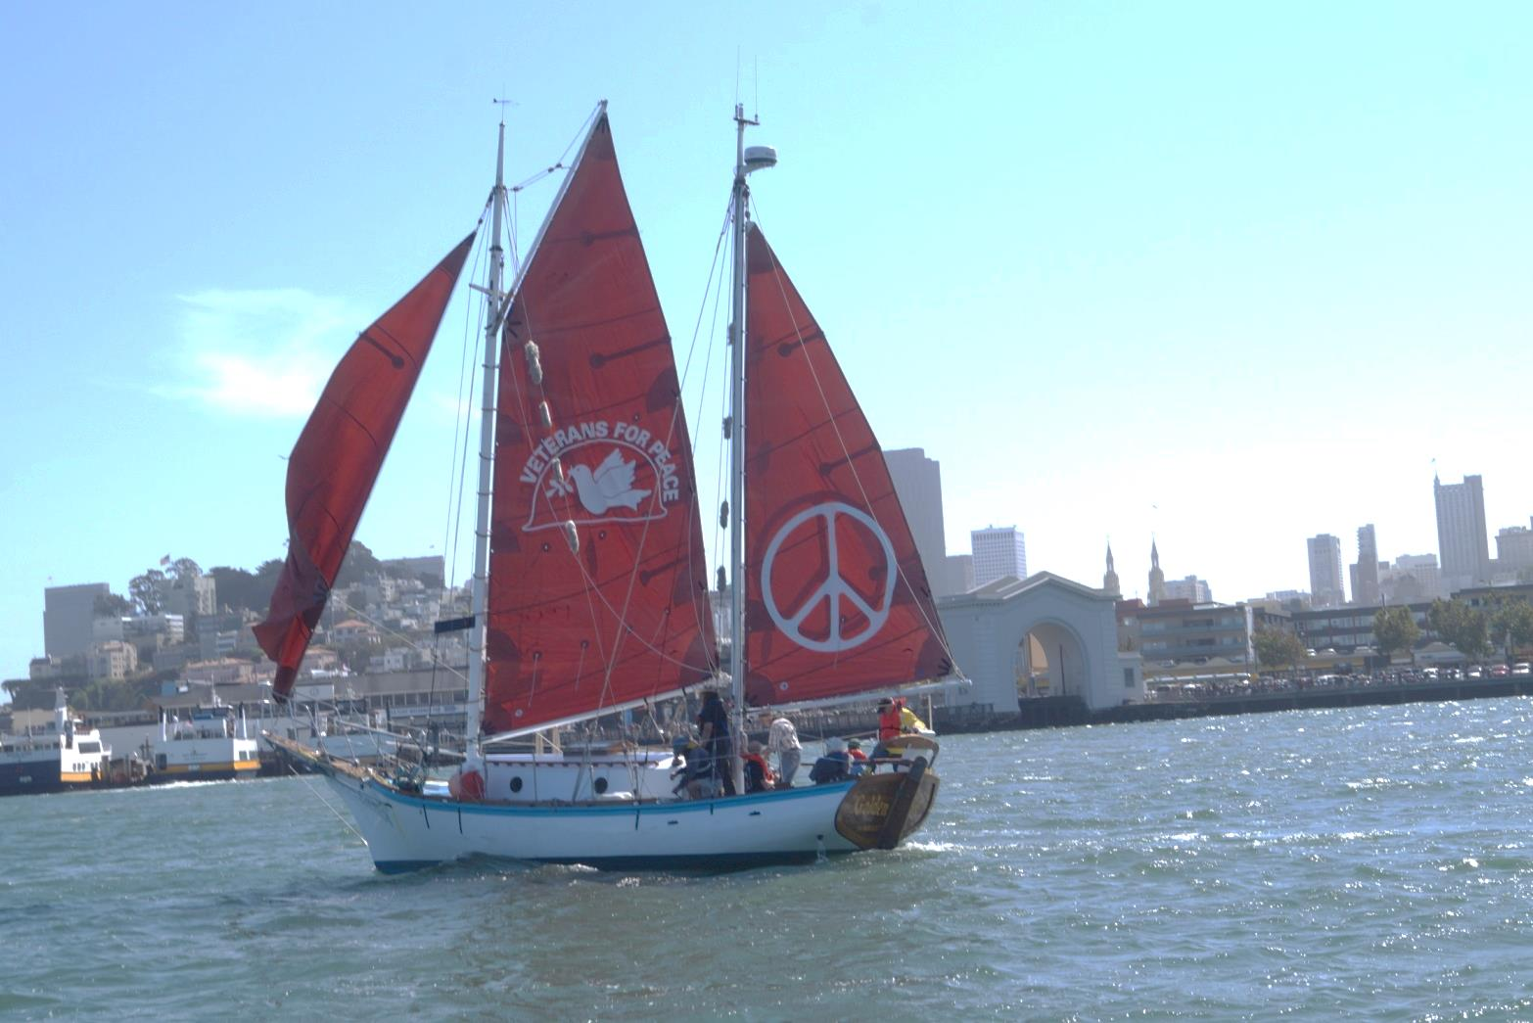

**Potluck with the *Golden Rule* Crew!**

**Friday June 10, 2016, 6:30 pm – 9:00 pm**

**Multnomah Friends Meeting, 4312 SE Stark St, Portland, OR**

In 1958 a crew of Quaker peace activists attempted to sail the *Golden Rule* to the Marshall Islands to interfere with US nuclear bomb testing. This bold nonviolent direct action inspired a worldwide movement leading to the Partial Nuclear Test Ban Treaty of 1963.

After five years of restoration by Veterans For Peace and many friends, the *Golden Rule* is once again sailing for a nuclear-free world and a peaceful, sustainable future!

**Meet the GOLDEN RULE CREW who are joining us for dinner**

**HELEN JACCARD, VFP Golden Rule Project Manager and crew member will give a presentation about the original voyage in 1958, the restoration from 2010 through 2015, the 2015 and 2016 voyages.**

**CAROL URNER, *Women’s International League for Peace and Freedom* will discuss the ways in which US and international groups are working for nuclear disarmament, including H.R. 1976, the bill before the US Congress to disarm and use the money for clean energy. Multnomah Meeting member.**

**CARL THATCHER, childhood reminiscences. Multnomah Meeting member.**

***Music with PETER FORD***

**Event sponsored by:**

**Peace and Social Concerns, Multnomah Meeting**

**Veterans For Peace Portland Chapter 72**

**Women’s International League for Peace and Freedom, Portland Branch**

For more information, call 971-282-9986, 503-224-0097 or 206-992-6364

**Free and open to public**

**Please bring a dish to share**