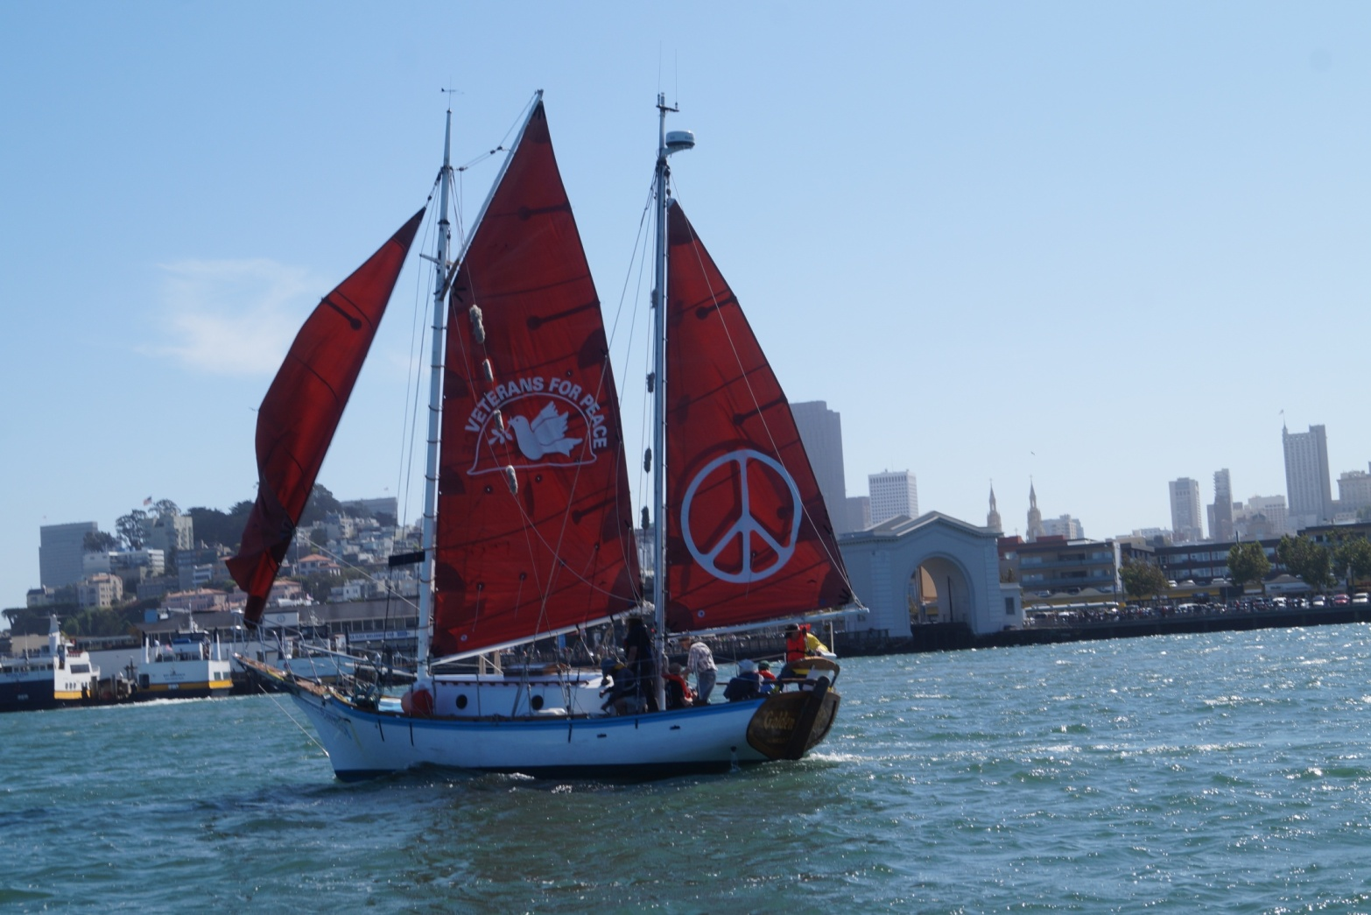

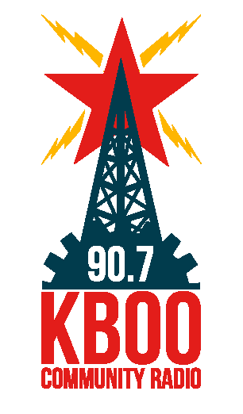

**Welcome the *Golden Rule*!**

**Wednesday June 8, 2016, 7:00 pm – 9:30 pm**

**First Unitarian Church, Eliot Chapel, 1011 SW 12th Avenue, Portland, OR**

In 1958 a crew of Quaker peace activists attempted to sail the *Golden Rule* to the Marshall Islands to interfere with US nuclear bomb testing. This bold nonviolent direct action inspired a worldwide movement leading to the Partial Nuclear Test Ban Treaty of 1963.

After five years of restoration by Veterans For Peace and many friends, the *Golden Rule* is once again sailing for a nuclear-free world and a peaceful, sustainable future!

**REV. GENKO RAINWATER, of Dharma Rain Zen Center, will lead a five-minute meditation**

**HELEN JACCARD, *Golden Rule* crew member**

**HARVEY WASSERMAN, *Solartopia*, Solar Energy proponent and vocal opponent of nuclear power**

**KIANNA JUDA-ANGELO,  *Living Islands* Marshall Islanders support organization**

**MIMI GERMAN, Founder of *No Nukes NW/RadCast***

**TERESSA RAIFORD, *Don't Shoot Portland***

**FRED SCHAFER, National Commander of the *National Association of Atomic Veterans***

**CHUCK JOHNSON, *Physicians for Social Responsibility,* works to close the Columbia Generating Station**

***Music by DAVID ROVICS***

Suggested donation: $10, nobody turned away

**Event sponsored by:**

**Veterans For Peace Portland Chapter 72**

**No Nukes NW**

**Alliance for Democracy Oregon**

**Education WithOut Borders**

For more information, call 971-282-9986 or 206-992-6364